Safe
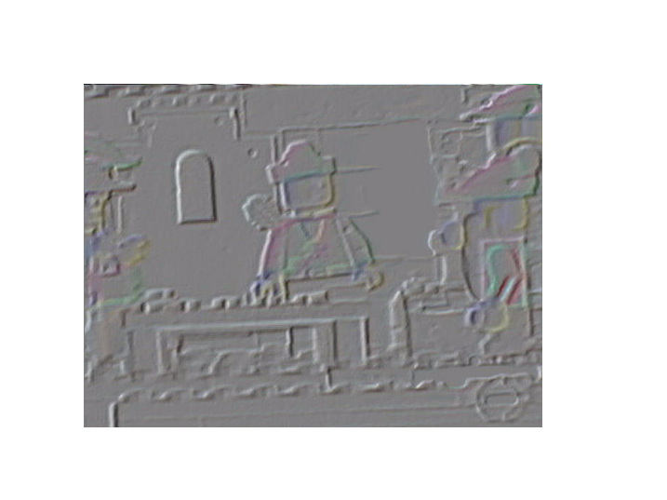
After loosing there air ship to griffin and falling in the lake the three forest men began to swim to shore. The current was strong but it seemed they could make it. 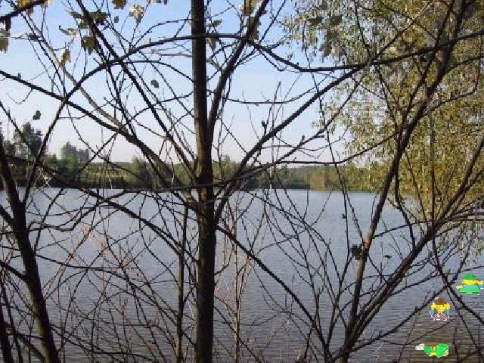 Until it got stronger. The man in brown grabbed the leg of the man with white trousers. The one in all green was drifting away so he used a lasso and lassoed the brown mans leg. It seemed all right when the forest man in front was about to reach the shore when the tide began to pull him back. As they all prepared to drone to death a man in a blue hat grabbed the man closets to the shore and pulled them all in. 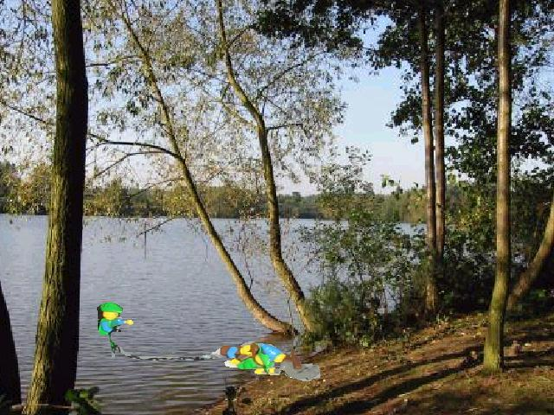
The man told them all to follow him to his campsite. He had already been cooking mice, bats, and some soup so at least there was food to eat. 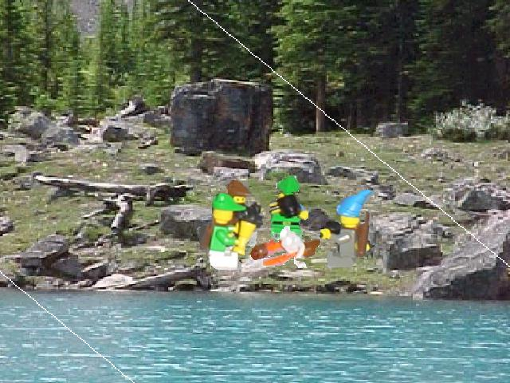
“So how did you guys manage to get stuck in that heap of trouble back
there?” the man in the blue hat asked. “Well uh” the forest man with white trousers
replied “ it is a long story”. The man just merely chuckled “ So do you guys have names or what”. “Link” he shouted “the idiot in the brown is Steve and the guy in green is Greg, so how about your name”. The man poked a mouse with his sword and played with it for while. “Well” Link hurried. “My name is Raddits,” He whispered. Then the sound of what
seemed to be horses. Raddits sprung up and yelled, “Lets go they should be here in ten minutes”. “Who?” Steve questioned. Raddits looked back and merely answered “I don’t know but they could give you us a ride to town”. When they got to the road they all just sat and waited for who ever had those horses to arrive. Steve took a nap while Greg and Link just sat. Then as the sound got louder a carriage appeared. Raddits ran towards it and yelled, “stop stop”.
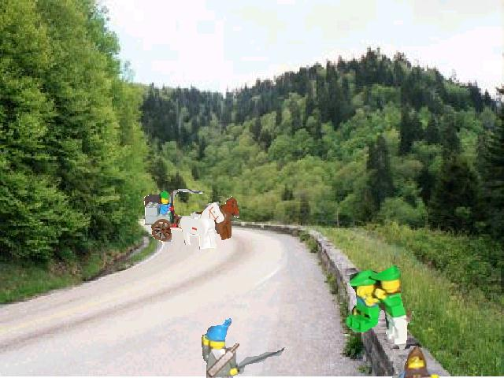The small cart then stopped. ”going to Calafrack?” Raddits asked. “Yep” the driver replied, “so get on and lets get going”. So they all hopped on the carriage and headed to town. Link figured the rest of the forest men might be there picking up some new weapons or food. The trip was long to pass the time they told Raddits the story about the griffin and how they crashed.
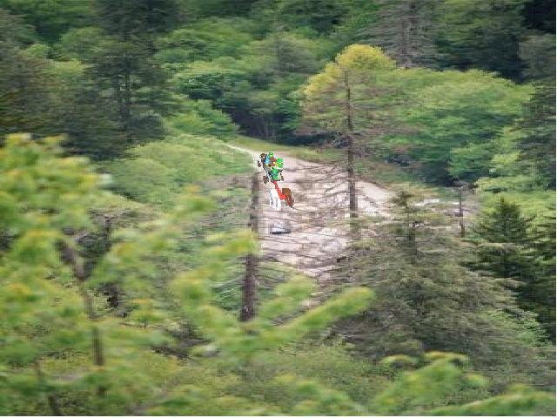As they entered the village everyone clear the was so the cargo could get to the shops. The people always enjoyed it when cargo carriage came. It was like show to them because they rarely ever saw such things. 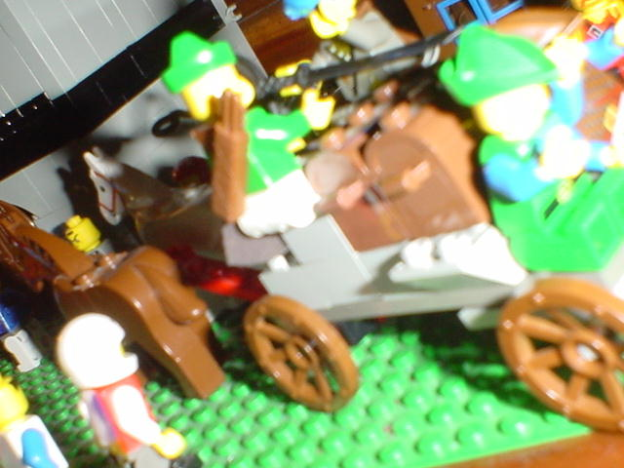Out of the crowd came three more forest men. Robin (in the brown with green hat) Sal (in the brown hat and green shirt) and Tom (in the brown hood). 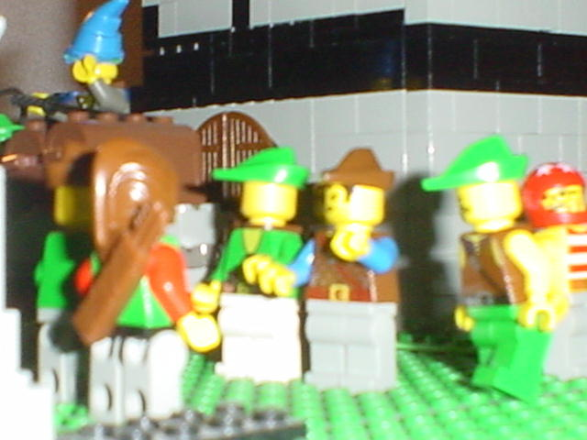 “Tom, Sal, Robin what’s up?” Steve said in an exited voice. Robin put is hand on Steve’s shoulder “the Boss wants you”. “Oh yea robin hold on let men introduce you to some one” Link interrupted. Link ran over to carriage and asked the driver “wear did Raddits go?” He turned to link “who the hat guy he just ran off after some bearded dude”. 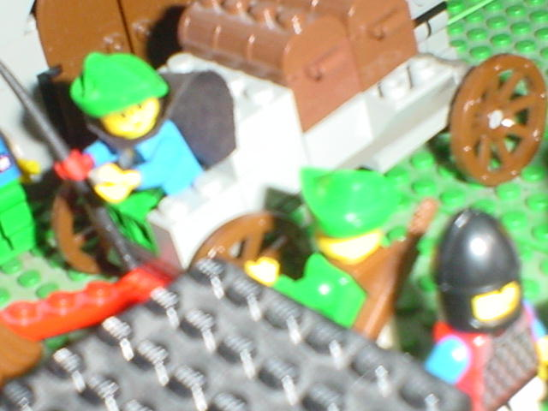Link just stood there thinking if Raddits mentioned a bearded guy ever. Then the boss came over to him and mumbled “Link”. Boss scared Link so he jumped back and screamed. The other forest men cracked up. Link looked over his shoulder seeing boss. He was a huge man. Double Links size so you could see how link was scared so easy. “LINK” He screamed. “ye ye yea B BO BOS BOSS” Link stuttered. “We need to talk about the griffin”. It was clear everyone respected and feared boss at the same time but everyone but Link including Boss himself knew link could take him. Now he wasn’t a special kid or given any gift by the gods. Link was just powerful clever and great with a sword.
The Boss, Robin, Steve and Link went to go talk to a dwarf from the village named Gien. Gien had a green cap and a green shirt. He used to lead the forest men. Now those days are over and he and anther dwarf, Guru, train two young kids, Mike and Danny. Both of them were almost as good with a blade as Link.
Boss came barging through the gates screaming “Gien we need to talk”. Gien Turned around and hit him on the head with a stick “knock next time, now lets go upstairs and talk”. 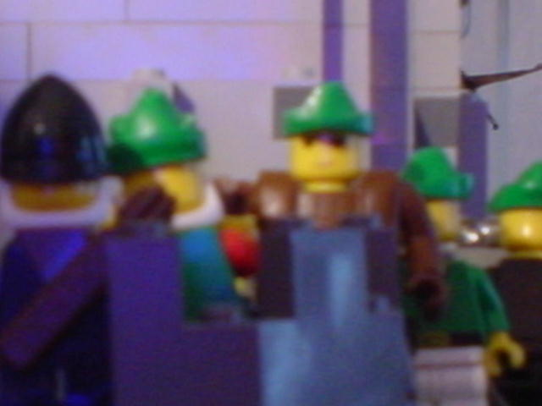So Boss, Robin, Steve, Gien, and Link went in the house to talk. Link and Steve told there Griffin story and so did Boss and Robin. Gien Paced and Told them that he would take Guru and the boys to investigate this griffin problem in this area. He then told the to find and repair the Forest Flyer And travel to other Lands in search of answers. 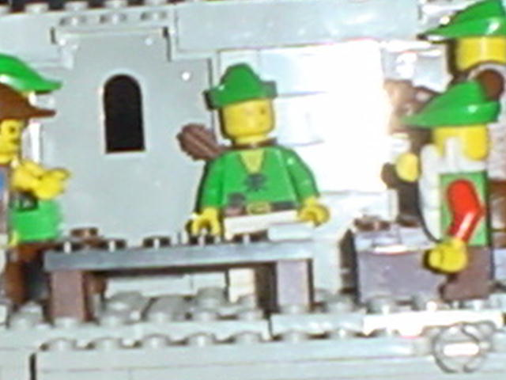

contact Vendezzz@aol.com for answers to questions.

