The Big Jet Engine Building Guide
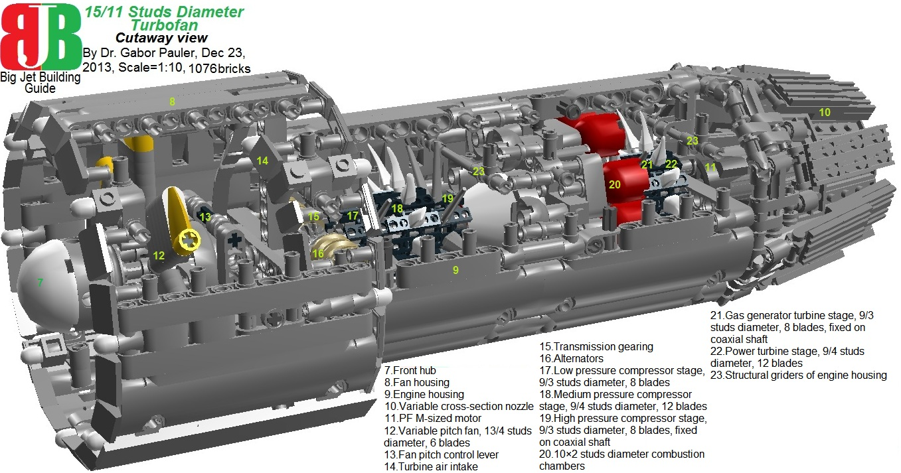
Functional models and building tricks of turbojet, turbofan, turboprop, turboshaft engines in scales 1:38, 1:20, 1:10
*Visit my <a href=http://www.legohelicopters.blogspot.com>Lego helicopters blog</a> also
**See all models in Lego Digital Designer (LDD): <a href=http://www.brickshelf.com/gallery/gjpauler/JetEngine/LargeTurboFan.lxf>Here</a>

<big><b><u>1.Introduction</b></u></big>

The purpose of this little handbook is to introduce MOCers community in building technologies of functional models of turbojet, turbofan, turboprop, turboshaft engines in scales 1:38, 1:20, 1:10.
This is necessary because we can see wide range of jet-powered MOCs inspired by “Hollywood science” (e.g.: total confusion of jet- and rocket engines, jet engines without air intake, VTOL crafts with pizza-sized rotors or without any stabilizer, etc.) being very far from basic principles of physics and engineering. TLG does not help very much the situation, as jet engine-related parts designed by Lego are smallish even by minifig scale (1:38), and technically they are at kindergarten-level, or contain basic design flaws:
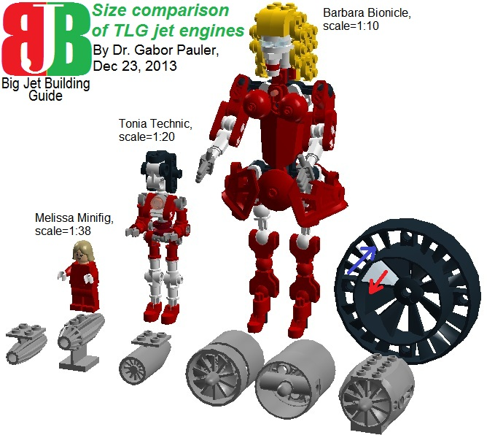
<b>Figure 1: We call three ladies (Melissa Minifig at scale 1:38, Tonia Technic at 1:20, Barbara Bionicle at 1:10) as aides for size comparison of TLG jet engine parts. The large 10 stud-diameter turbine part has positive pitch at outer blades and negative pitch in inner blades. So if you turn it, it pumps air pointlessly in opposite directions (but still could be used as stator vanes in jet engines)</b>
See the 3 ladies and TLG jet engine parts in LDD: <a href=http://www.brickshelf.com/gallery/gjpauler/JetEngine/LegoJetEngines.lxf>Here</a>

In the meantime, professional high-end Lego builders of <a href=http://www.bright-bricks.com/> Bright-Bricks</a> built wonderful functional model of Rolls Royce Trent 1000 turbofan in scale 1:2 from more than 150000 bricks:
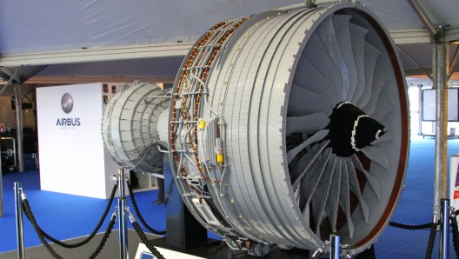
<b>Figure 2: Rolls Royce Trent 1000 by Bright-Bricks </b>

But in everyday model scales of 1:38, 1:20, 1:10, and from budget affordable to everyone, nobody tried to build functional model of jet engines. One rare exception on MOCPages is MT Racing Corporation’s <a href=http://www.mocpages.com/moc.php/375363>turbofan engine</a> in scale 1:20:
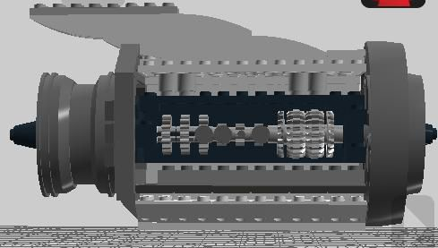
<b>Figure 3: MT Racing Corporation’s turbofan</b>
In this guide, we show how to build functional AND affordable jet engines in scales 1:38, 1:20, 1:10 at more sophisticated level:
- We want them fully comply with physics and real engineering principles: “Whatever you see there is working correctly”.
- Therefore, we did not put on them any decorative, non-functional parts to make them similar to any given real engines. But you are free to use them in your models and modify them that way.
- At the end of the handbook, you can find list of useful building tricks at designing your own jet engines.
- We present our engines from less complicated, easier to build, large sized ones to more complicated ones. Our innovations and experiences culminate in Lego modeling “King of all engines”: F-35 Joint Strike Fighter’s Pratt & Whitney F135 STOVL turbojet:

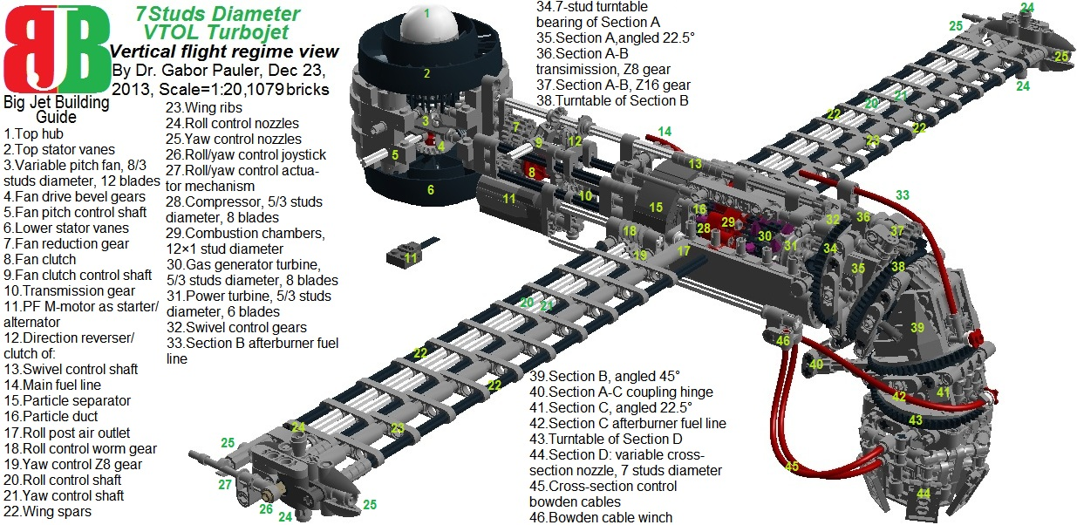
<b>Figure 4: VTOL turbojet engine like F-35 Joint Strike Fighter’s Pratt & Whitney F135 in vertical flight regime</b>
See model in LDD: <a href=http://www.brickshelf.com/gallery/gjpauler/JetEngine/F35STOVLJetEngineDownward.lxf>Here</a>

<big><b><u>2.Family of 11 studs-diameter jet engines</b></u></big>

*This part is technical and for aircraft/heli builders with at least some technical background. If you do not understand how do different types of jet engines work, you can find an excellent summary at <a href=http://en.wikipedia.org/wiki/Jet_engine>Wikipedia</a>. We just put here a short summary image:
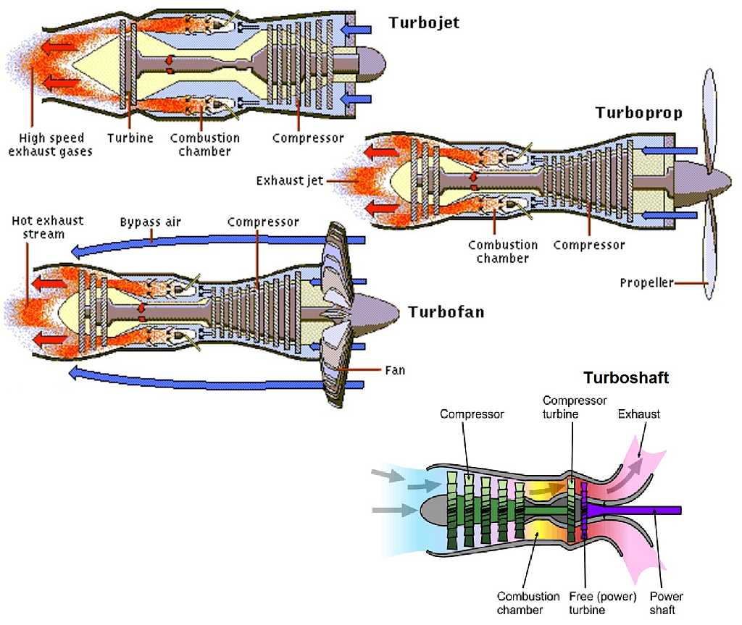
<b>Figure 5: Operating principles of different types of jet engines </b>
**In the forthcoming technical description, functional parts of jet engines are referenced by numbers which can be found on technical drawings attached.
***Parts of jet engines are color-coded by their function:
- Gray/Black: Static parts
- White: Drive/control shafts
- Yellow: Rotor blade tips or propeller hub peaks
- Purple: Turbine rotor blades
- Red: Combustion chambers
- Light yellow: Alternators

<b><u>2.1. 11 studs-diameter turbojet</b></u>
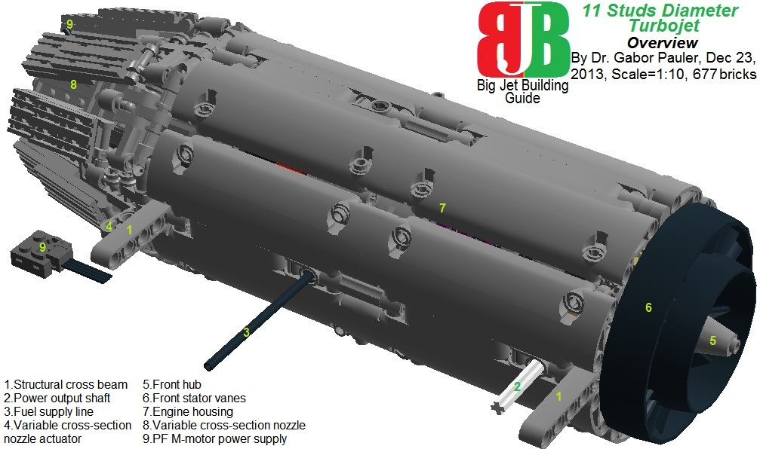
<b>Figure 6: Overview of 11 studs-diameter turbojet </b>
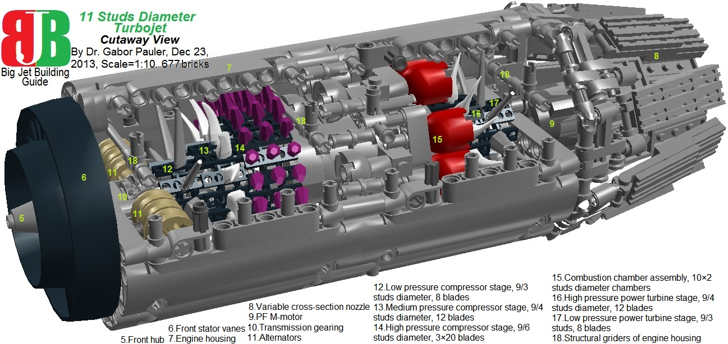
<b>Figure 7: Cutaway view of 11 studs-diameter turbojet </b>
Our first engine is a medium size, side-mounted turbojet in scale 1:10. Or it is a supersized one in scale 1:20. It is the only model in this handbook, which doesn’t have coaxial main shaft, because I experimented here with multiple stages of compressor and gas generator turbines. Also, this is the only engine where I used the 9 studs outer- / 6 studs inner diameter 3 rows × 20 blades super high pressure compressor rotor (see 14 on Figure 7). Its hub is made of 20 3-studs wide track elements rolled around a 5 stud diameter Z40 gear. The large size of the engine allowed to place its own electric drive at the rear hub as a Power Functions (PF) M-sized motor. Moreover, it has an auxiliary power output shaft (see 2 on Figure 8) to drive fuel pumps or other onboard systems. All engines in this handbook have working variable cross-section nozzle cones. The current nozzle has double octagonal layout, with 8 universal joints connected in a ring by 3 stud-rods, moving 16 flaps. Inner side of the flaps are smooth to create minimal drag, outer side has cooling radiators.
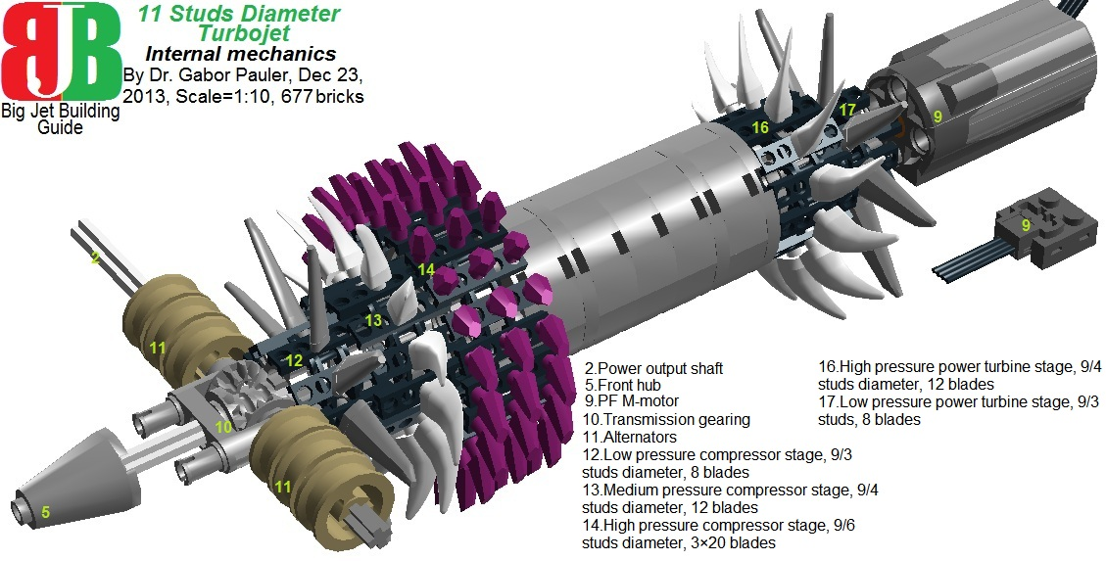
<b>Figure 8: Internal mechanics of 11 studs-diameter turbojet </b>
See model in LDD: <a href=http://www.brickshelf.com/gallery/gjpauler/JetEngine/LargeTurboJet.lxf>Here</a>

<b><u>2.2. 11 studs-diameter turboshaft</b></u>
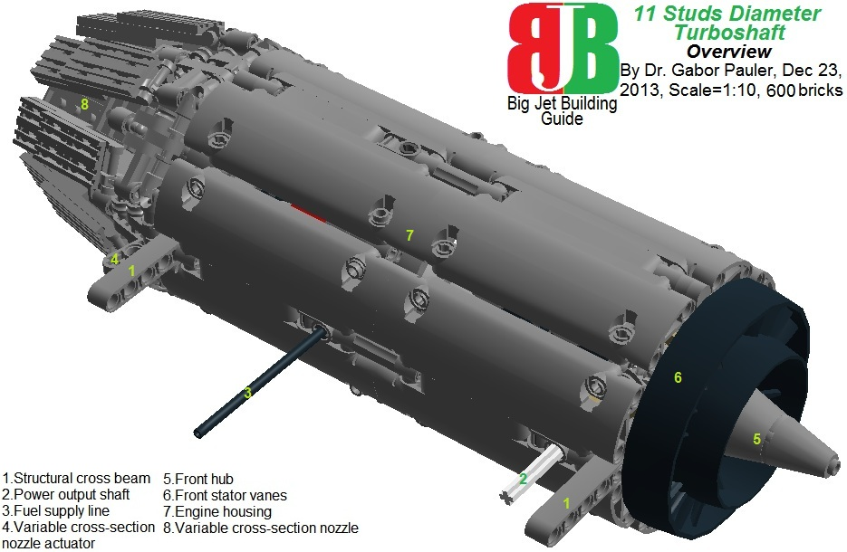
<b>Figure 9: Overview of 11 studs-diameter turboshaft </b>
In external view, this engine looks very similar to previous one, but internally, it is completely different. Its high pressure compressor stage and gas generator turbine stage (both 9/3 studs diameter, 8 blades) are fixed on a coaxial shaft.
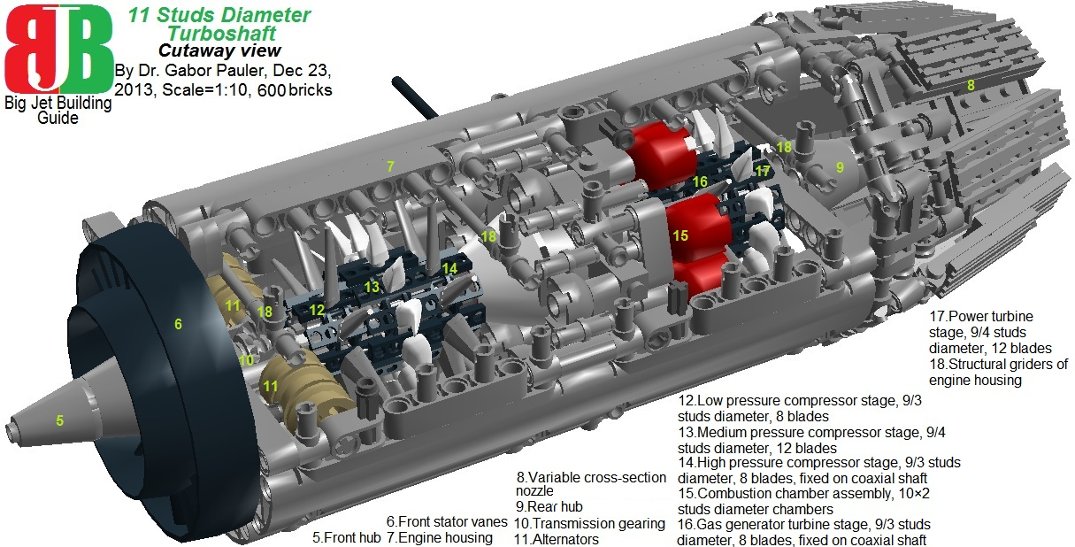
<b>Figure 10: Cutaway view of 11 studs-diameter turboshaft </b>
One basic shortcoming of Technic is the almost complete lack of coaxial tube shaft-like parts. Therefore, coaxial shaft is made from Technic gear shift parts (see 14 and 16 on Figure 11): pair of ‘Gear wheel Z16’ parts support each compressor/ turbine rotors, and driving- and middle rings connect them, running freely on main shaft. Therefore, main shaft is made of single 32 stud-long Technic axis. Its length does not allow to place PF M-motor in rear hub. So this engine should be driven externally through its power output shaft. As turboshafts are mostly used in helicopter models, where there are electric motors to drive rotors anyway, this is not an issue.
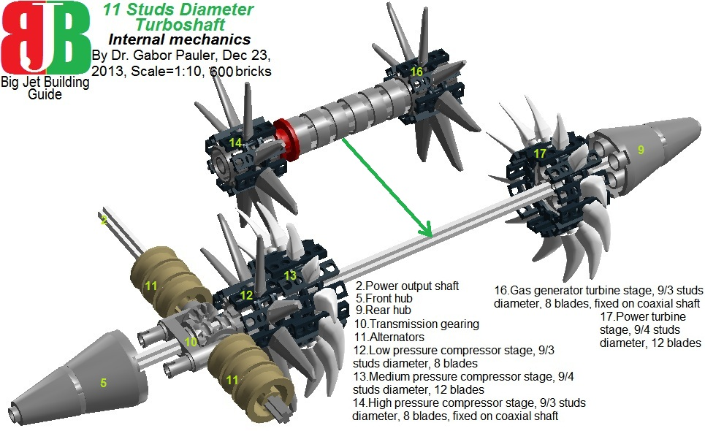
<b>Figure 11: Internal mechanics of 11 studs-diameter turboshaft </b>
See model in LDD: <a href=http://www.brickshelf.com/gallery/gjpauler/JetEngine/LargeTurboShaft.lxf>Here</a>

<b><u>2.3. 15/11 studs-diameter turbofan</b></u>
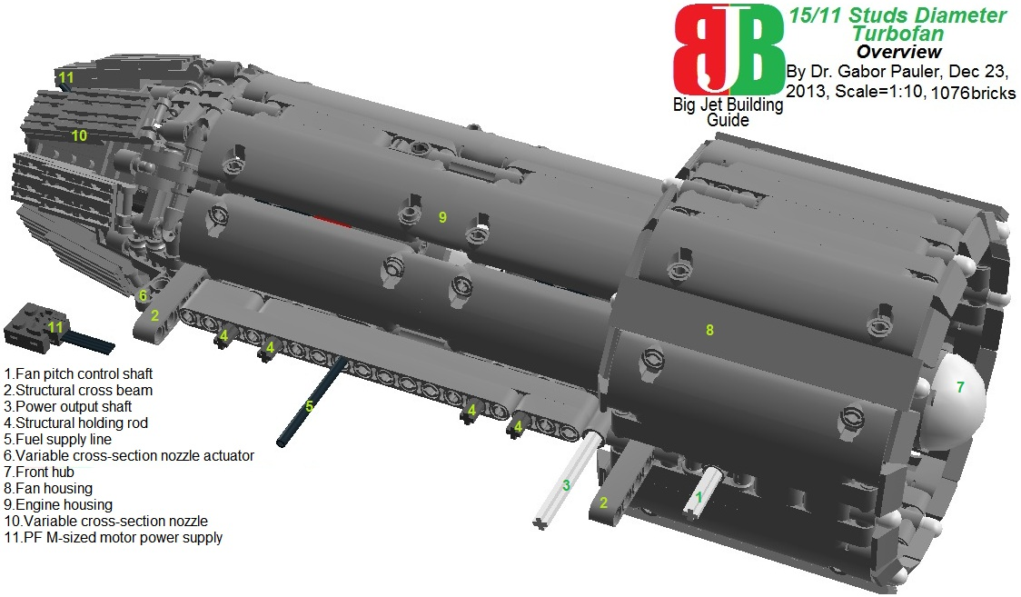
<b>Figure 12: Overview of 15/11 studs-diameter turbofan </b>
Our largest engine is based on the previous turboshaft. It can be used as medium sized turbofan (eg. at some business jets) in scale 1:10, or full size airliner engine in scale 1:20. We have PF M-sized motor in the rear hub again, so 32 stud-long main shaft extends forward to support a 13/4 studs diameter, 6 blade, variable pitch fan.
<b>Figure 13: Cutaway view of 15/11 studs-diameter turbofan </b>
Most airliner turbofans have fixed pitch fans, but creating variable pitch fan was a modeling challenge, and it has special benefits in STOL (Short Take Off Landing) military applications. As pitch of fan blades can be set from +25 degrees to – 25 degrees with pitch control lever (see 13 on Figure 14), it can be used as reversed trust engine brake at landing. At takeoff, one should spin engine to maximal rpm at blade pitch set to zero, while landing gear brakes are deployed. Then suddenly release brakes and increase blade pitch enables the aircraft to make jumpstart on short runways. Moreover, differential pitch control of left- and right engines can substitute disabled rudders in emergency.

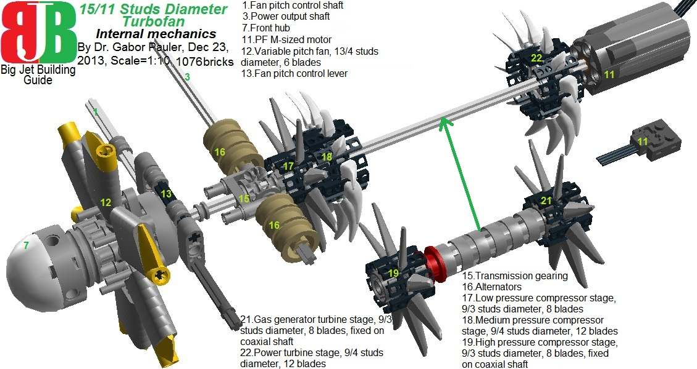
<b>Figure 14: Internal mechanics of 15/11 studs-diameter turbofan </b>
See model in LDD: <a href=http://www.brickshelf.com/gallery/gjpauler/JetEngine/LargeTurboFan.lxf>Here</a>

Besides autonomous electric drive, we kept the power output shaft at the side of the engine to drive onboard systems. Because of its size, its variable pitch fan and its output shaft, you can use this engine at futuristic VTOL crafts, based on 4 tilting turbofans/ ducted fans (something similar to <a href= http://en.wikipedia.org/wiki/Bell_X-22>Bell X-22</a>):
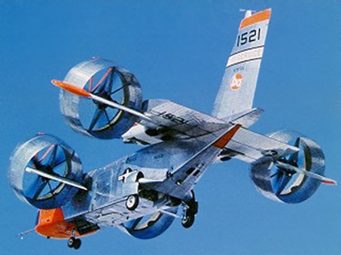
<b>Figure 14b: Bell X-22 experimental VTOL craft </b>

<big><b><u>3.Family of 7 studs-diameter jet engines</b></u></big>

This family of engines best fits to scale 1:20, or as medium sized helicopter engines to scale 1:10. The size reduction has serious advantage on materials requirement: brick count is roughly halved comparing to previous family of engines. But in smaller size, lack of specialized TLG turbine parts starts to creep in the background: to save space, we have to omit multi-stage compressors and turbines, separate combustion chambers, internal electric drive, which are common in previous family.

<b><u>3.1. 7 studs-diameter turbojet</b></u>
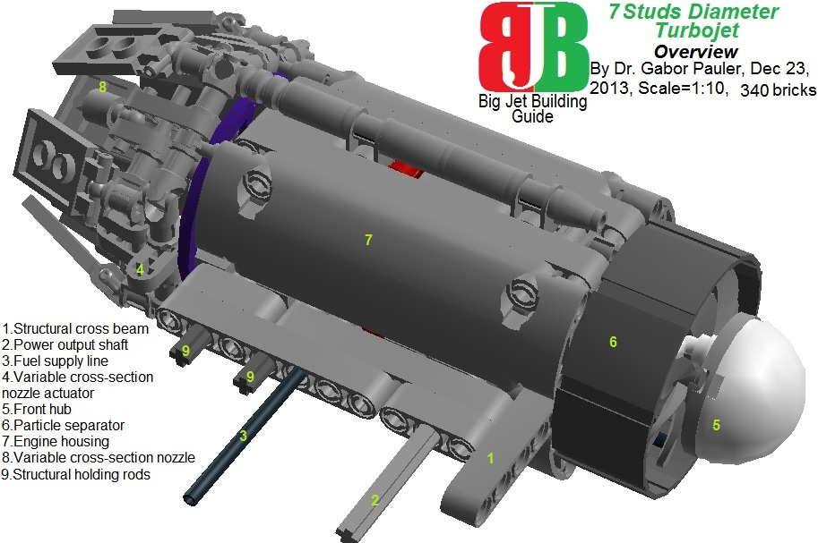
<b>Figure 15: Overview of 7 studs-diameter turbojet </b>
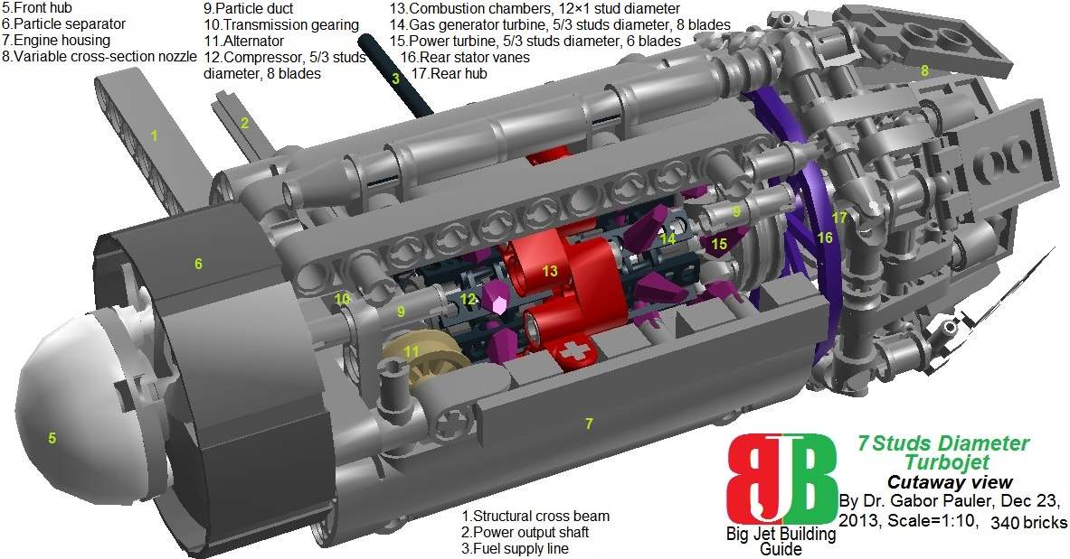
<b>Figure 16: Cutaway view of 7 studs-diameter turbojet </b>
This turbojet has coaxial shaft, but its compressor, gas generator turbine and power turbine have only one stage. However there is an extra feature compared to the bigger turbojet: a centrifugal type particle separator mainly used in helicopter engines. It prevents dust and particles sucked in to enter into compressor and destroy that. Spun-up particles fly into particle ducts bypassing the engine driven by their centrifugal force, while most of the clean air enters into the compressor. This feature is created with the help of parts ‘Propeller 48mm with snap’ and ‘Wheel 56×22mm with spokes’ serving as a trap for particles. Due lack of space, aft bearing of main shaft is solved with part ‘Spoked wheel 56mm’ used as rear stator vanes.

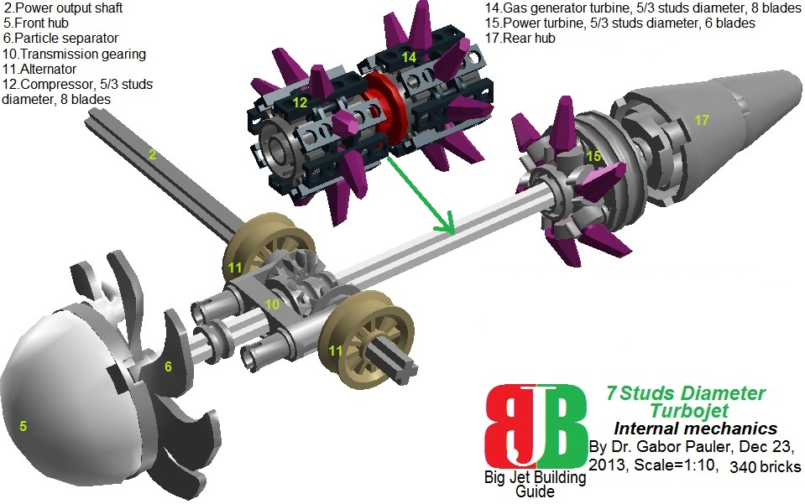
<b>Figure 17: Internal mechanics of 7 studs-diameter turbojet </b>
See model in LDD: <a href=http://www.brickshelf.com/gallery/gjpauler/JetEngine/TurboJet.lxf>Here</a>

<b><u>3.2. 7 studs-diameter turboshaft</b></u>
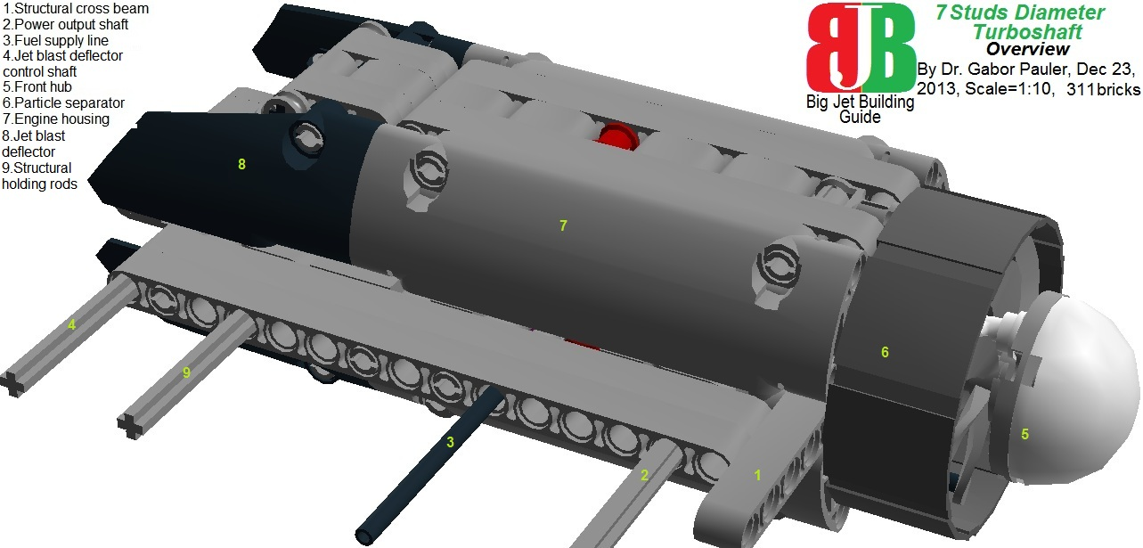
<b>Figure 18: Overview of 7 studs-diameter turboshaft </b>
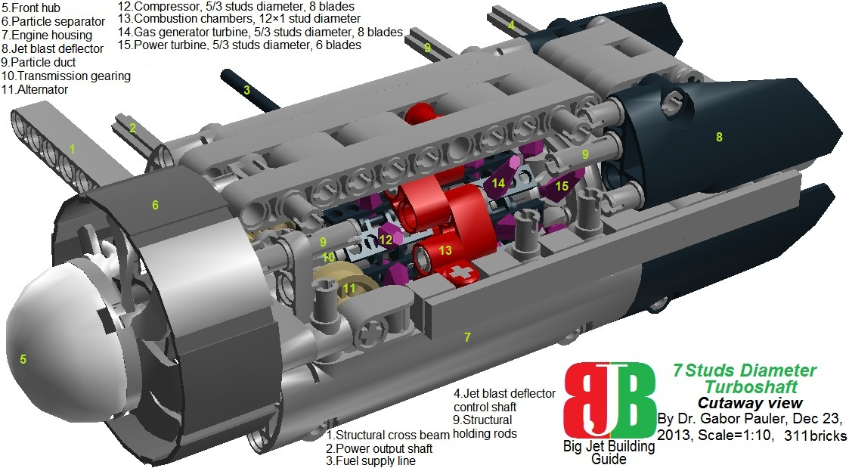
<b>Figure 19: Cutaway view of 7 studs-diameter turboshaft </b>
This engine is almost identical to the previous one, except that it has jet blast deflector instead of variable-cross section nozzle. The deflector can be adjusted with a control shaft to deflect jet blast from -45 degrees to +45 degrees from horizontal, and allowing it to mix with cold air through an opening flap (see the blue arrow at Figure 20). This is a usual solution at most battlefield helicopters to prevent enemy IR-homing missiles to capture heat signal of the engine.

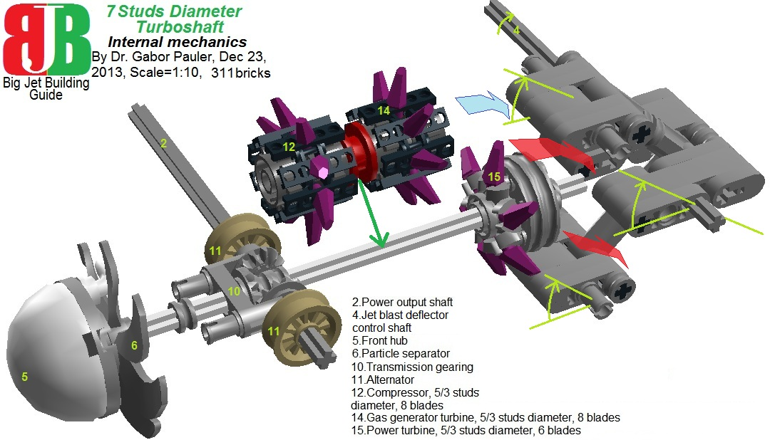
<b>Figure 20: Internal mechanics of 7 studs-diameter turboshaft </b>
See model in LDD: <a href=http://www.brickshelf.com/gallery/gjpauler/JetEngine/TurboShaft.lxf>Here</a>

<b><u>3.3. 11/7 studs-diameter turbofan</b></u>
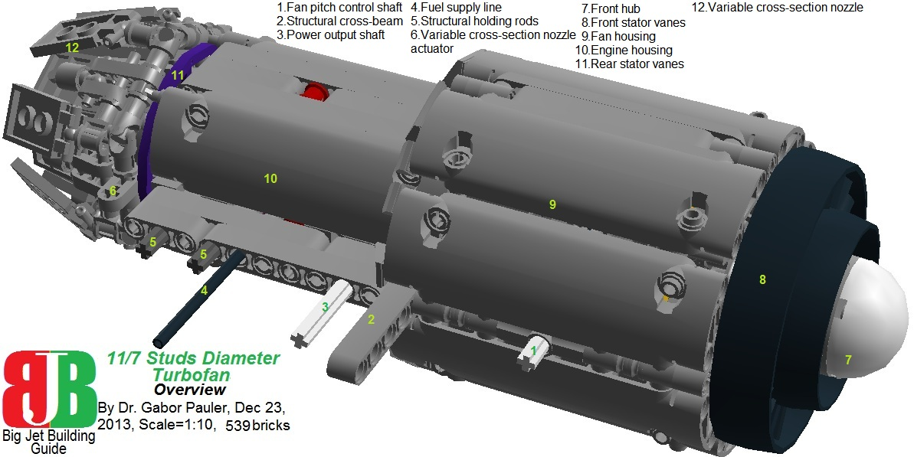
<b>Figure 21: Overview of 11/7 studs-diameter turbofan </b>
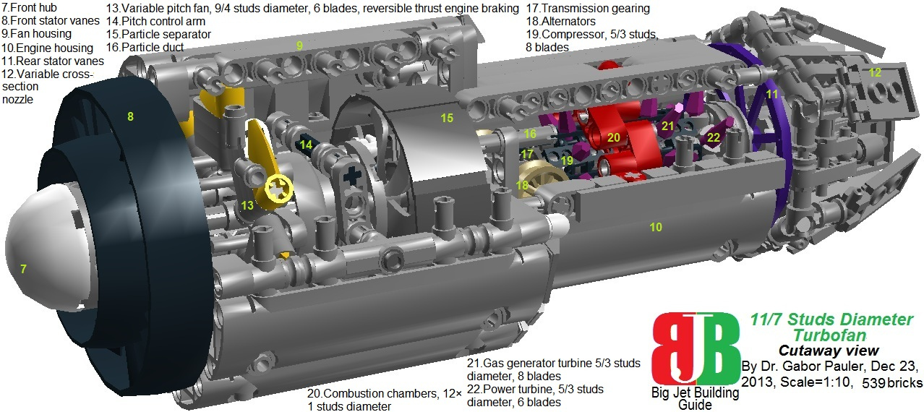
<b>Figure 22: Cutaway view of 11/7 studs-diameter turbofan </b>
In this family of engines, we developed two types of turbofans. The first one is shorter with larger diameter fan housing (11 studs instead of 10) being suitable for small sized turbofan in scale 1:10 or medium sized in 1:20. The particle separator makes it suitable to use from unpaved runways in military transport application. Compared to its larger brother, multi-stage compressor and internal electric drive is lost due to the size reduction, but we managed to keep variable pitch fan with reverse thrust engine brake function.
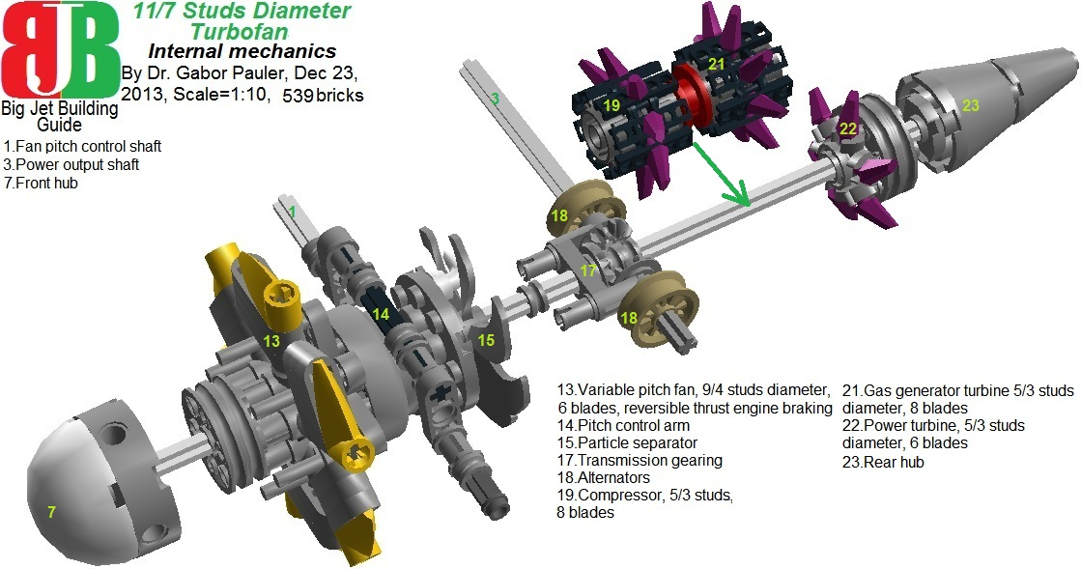
<b>Figure 23: Internal mechanics of 11/7 studs-diameter turbofan </b>
See model in LDD: <a href=http://www.brickshelf.com/gallery/gjpauler/JetEngine/TurboFanLong.lxf>Here</a>

<b><u>3.4. 10/7 studs-diameter turbofan</b></u>
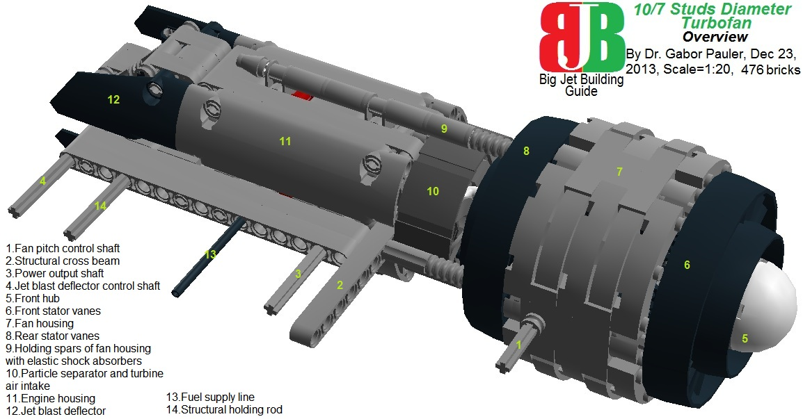
<b>Figure 24: Overview of 10/7 studs-diameter turbofan </b>
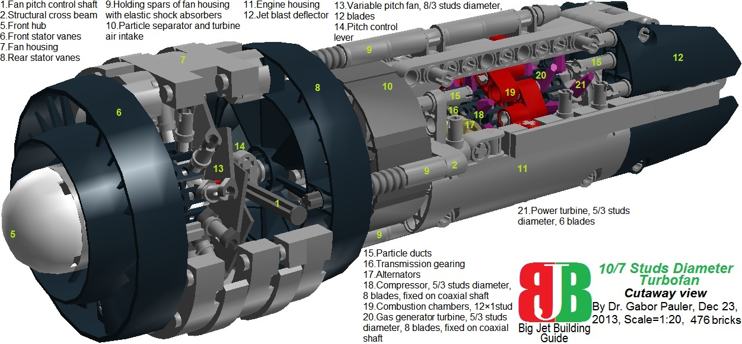
<b>Figure 25: Cutaway view of 10/7 studs-diameter turbofan </b>
Our second turbofan in this family of engines is sleeker and longer, and it is equipped with jet blast deflector instead of variable cross-section nozzle. These features make it suitable for stealth aircraft in scale 1:20.

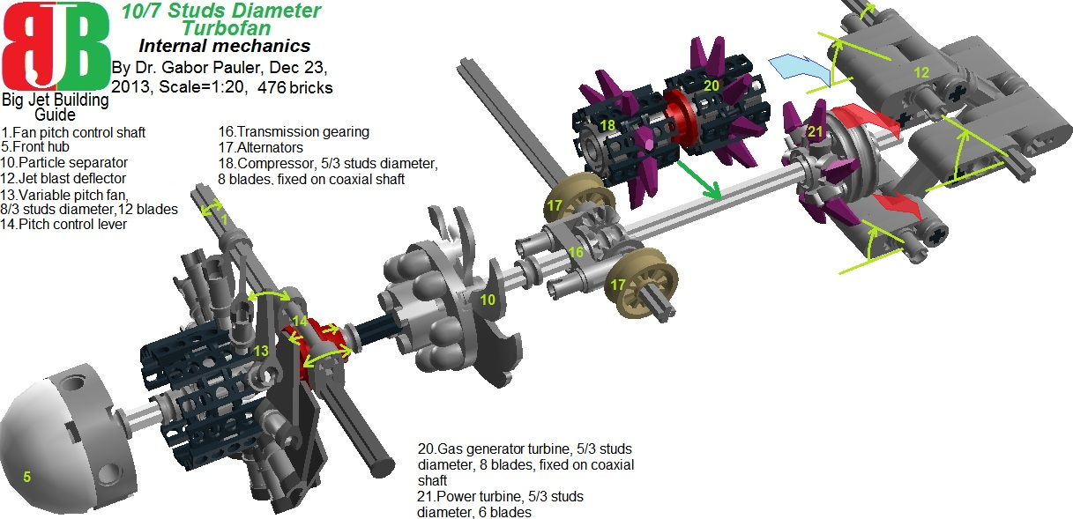
<b>Figure 26: Internal mechanics of 10/7 studs-diameter turbofan </b>
See model in LDD: <a href=http://www.brickshelf.com/gallery/gjpauler/JetEngine/TurboFanShort.lxf>Here</a>

<b><u>3.5. 21/7 studs-diameter turboprop</b></u>
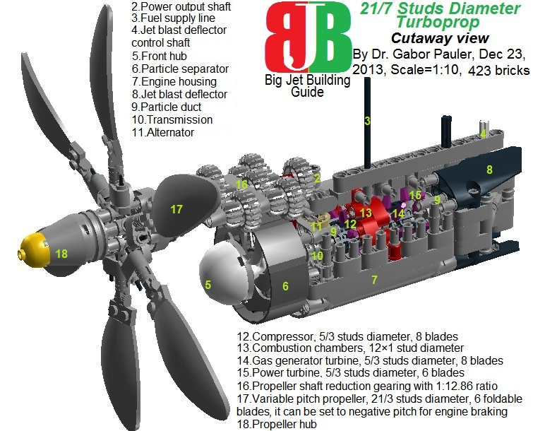
<b>Figure 27: Cutaway view of 21/7 studs-diameter turboprop </b>
See model in LDD: <a href=http://www.brickshelf.com/gallery/gjpauler/JetEngine/TurboProp.lxf>Here</a>

As wide range of smaller transport aircraft have turboprop engines, we could not resist the modeling challenge to create one from our previously presented 7 stud-diameter turboshaft. Propellers are always troubleful in Lego, as TLG parts are smallish even in minifig scale, and variable pitch version was never-ever attempted. We present here an unfinished draft of a turboprop, just to present our largest, 21 stud-diameter, 6-blade, variable pitch propeller. It tries to model the modern, highly efficient variable pitch turboprop propellers (low rpm, usage of many wide blades).

<b><u>3.6. 7 studs-diameter VTOL turbojet</b></u>

When I first saw Lockheed-Martin’s ‘shaft driven lift fan + 3 bearing swivel duct’ VTOL concept in 1999, I thought that it nice but totally unrealistic. Billions of taxpayer dollars made it possible. In average, all Americans from newborn babies to their grandmas spent quite a couple of bucks to reach first full scale VTOL application of F-35 at the beginning of 2013.
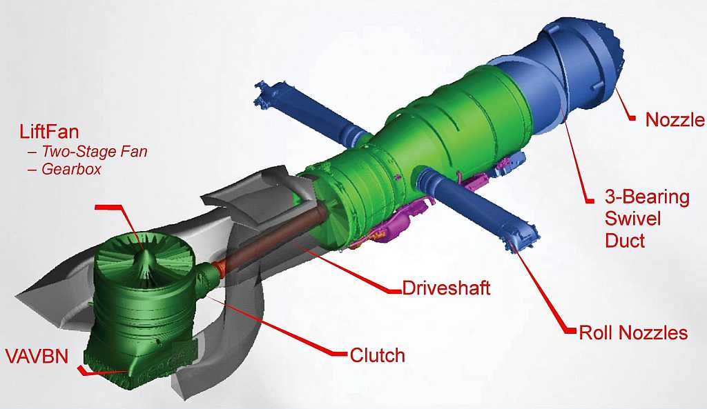
<b>Figure 28: Draft view of F-35 STOVL Engine</b>
First I thought that modeling the 3 bearing swivel mechanism from Lego in working condition would be a pure madness. But gears already started to grind in my head to show, that – against “stick that nozzle at the bottom” style solutions – how painfully complicated and expensive can be a realistic VTOL engine. It is still a very strong simplification of the real stuff:
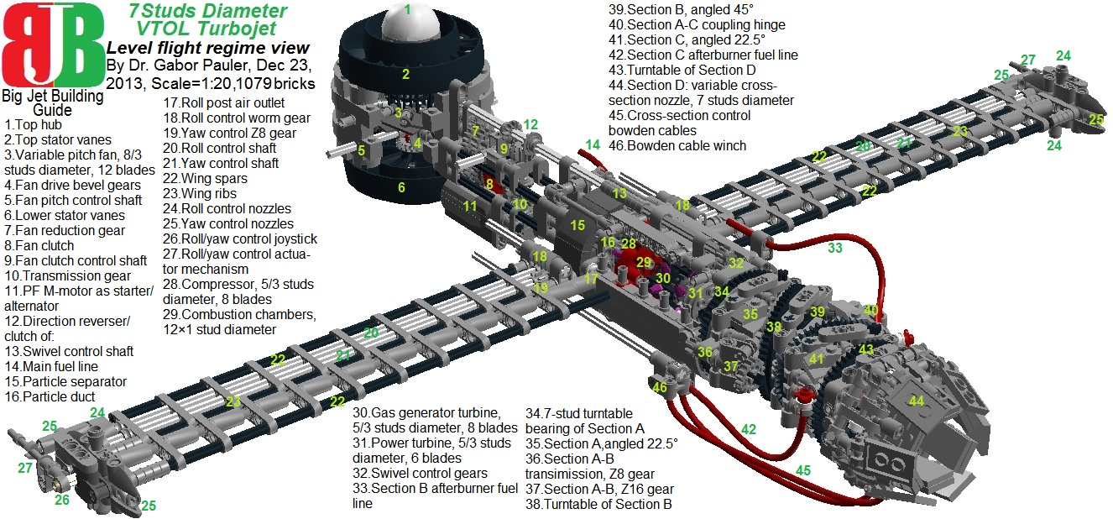
<b>Figure 29: Cutaway view of 7 studs-diameter VTOL turbojet in horizontal flight regime</b>
The key to the solution were parts ‘Turntable 3/7 studs’ acting as three large diameter bearings with holes in their middle. From the engine housing backward, three sections (A, B, C) of toroid section-shaped short tubes had to be constructed around them (with 22.5, 45.0, 22.5 degrees of turn respectively), to allow nozzle to turn from 0 degrees to -90 degrees:
<b>Figure 30: Cutaway view of 7 studs-diameter VTOL turbojet in vertical flight regime </b>
To achieve this, sections A and C should swivel +90 degrees, while section B should swivel -90 degrees synchronized. In the reality, there are separate electric servo motors for all sections, but this was not an option here as size of even the smallest PF electric motor was too big. Therefore, we solved swivel control with a complicated mechanics (see Figure 31): On the main shaft of the engine, there is a transmission gearing (10) from 3 half bevel gears. One of them connects drivetrain to a PF M-sized electric motor driving the engine (acting as alternator/ starter motor). The other half bevel gear connects main shaft to a direction reverser/ clutch (12) made of another 3 half bevel gears. As swivel control shaft (13) can slide 0.25 studs forward/ backward during rotation, it can be driven by (12) clutch in both directions. It transmits drive through series of 4 Z8 gears (32) to the 7-stud turntable of Section A (34). The turntable’s outer Z56 gear is fixed to engine housing, while Z24 inner gear is driven by (32) Z8 gears. As Section A is rotated +90 degrees to transform duct from horizontal to vertical, (13) swivel shaft should rotate -270 degrees for that. Section A has 22.5 degrees turn in gas stream, and it is equipped with a driving shaft (36, 37), transmitting swiveling drive. When Section A is rotated, Z8 gear (36) rotates +630 degrees on the Z56 gear of the turntable fixed to engine housing. On the same driving shaft, there is a Z16 gear, driving Z56 gear of the turntable for Section B (38) -180 degrees relative to Section A. As Section A rotates +90 degrees relative to engine housing, Section B will rotate +90 -180 = -90 degrees relative to engine housing, and that’s exactly we want. Section C should rotate +90 degrees relative to engine housing, just like Section A. Therefore, there is a hinge (40) connecting Section A and C to make their rotation coupled. Section B and C have afterburners built in, supported by flexible fuel lines (33, 42). Section D is the 7.5-stud diameter variable cross-section nozzle assembly, and it has a fourth 7-stud diameter turntable. This fourth bearing is NOT necessary for the geometry of the 3-bearing swiveling duct, but it is to make nozzle control easier: As nozzle will rotate +90 degrees, turns downward -90 degrees, and moves closer relative to engine housing simultaneously during horizontal-vertical transition, controlling cross-section of nozzle should be solved some kind of a remote control. In the reality, it has hydraulic actuators (manufactured by Moog Inc., East Aurora, NY) supported by flexible high pressure hydraulic lines and electronic signals of the fly-by-wire system. I tried to model it with both Lego pneumatic jack and linear actuator driven by PF M-sized electric motor, but they were just too bulky and cumbersome to place them on the moving Section D nozzle unit. Therefore, finally I opted for double Bowden cables (45), where cable is driven by winch (46) fixed on engine housing, and rotates a spool placed on one of the 3 stud shafts connecting 6 universal joint parts into a hexagonal ring at the nozzle assembly.
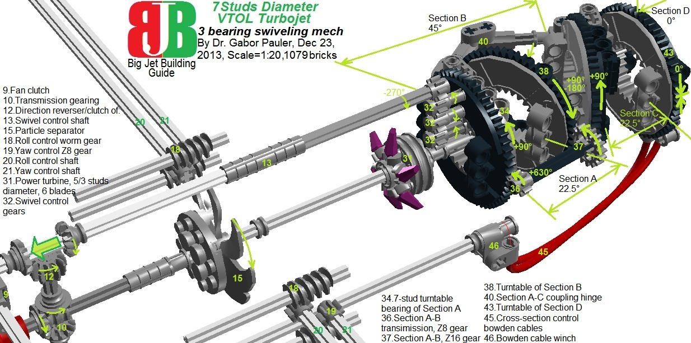
<b>Figure 31: 3-bearing swiveling mechanism of 7 studs-diameter VTOL turbojet </b>
At stabilizer roll posts, I did not follow strictly the structure of roll posts in F-35 engine. The problem is that in Lego it is very hard to make thin, streamlined and swept back wings (of course SNOT ones). The original roll posts are short but thick tubes, which would make it even more hard. Therefore I used Harrier GR-style roll posts, which are thin, long, with nozzles built in the wingtips (see Figure 31b). In a 1 stud-thick structure of wing spars (22) and wing ribs (23), a compressed cold air duct (17) runs from the outlet at engine housing (which is placed just aft compressor blades and before combustion chambers) to 4-nozzle assemblies at wingtips (24, 25). In each nozzle assembly, a joystick rotates in a ball joint (26), which can distribute compressed air among the 4 nozzles (see blue arrows on Figure 31b). When the joystick is at center position, roll/yaw control is neutral, as exactly the same amount of air goes up/down and left/right. If the joystick is moved one direction, more air goes to the opposite direction, creating steering torque. The problem here was again that we needed two small servos to actuate the joystick, which we did not have in Lego. So we solved this with a hinge mechanism (27), actuated by yaw- and roll control shafts running inside the wing (20, 21), and worm gear + Z8 gear combos (18, 19) placed at wing roots. Both roll posts can perform roll- and yaw control independently, so they are redundant for safety reasons. The price for this is the higher drag of the 4 nozzle assemblies, and joystick assembly prevents wingtip mounting of missile launching rails (E.g. Sidewinder).
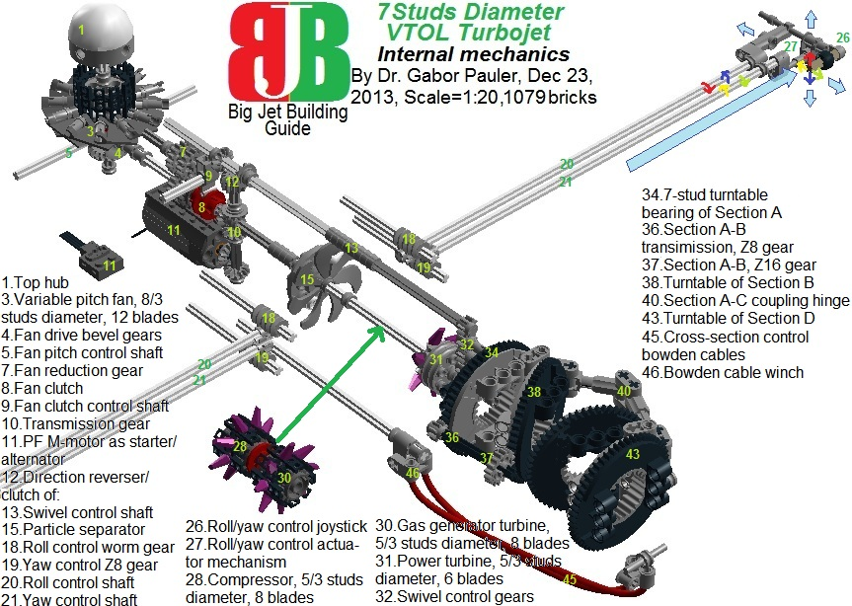
<b>Figure 31b: Internal mechanics of 7 studs-diameter VTOL turbojet </b>
See model in LDD: <a href=http://www.brickshelf.com/gallery/gjpauler/JetEngine/F35STOVLJetEngine.lxf>Here</a>

I used a combination of parts ‘Driving ring’ and ‘Gear wheel Z16’ to create a clutch (7, 9), which connects driving shaft (extension of main shaft forward) to a pair of Z20 half bevel gears (4) which drive the 8 stud-diameter, 12 blade, variable pitch lifting fan (3). Fan pitch can be controlled by shaft (5). The VAVBN unit is omitted from the bottom of lift fan for the sake of simplicity. Even this way we already have 8 shafts to control the engine: 1. Fan pitch, 2.Fan clutch, 3.-4. Yaw control, 5.-6. Roll control, 7. Swivel control, 8. Nozzle control. That’s quite different story than sticking nozzles beneath a box and claiming it VTOL… For Star Wars fans, anti-gravity device is always in the backyard…

<big><b><u>4.Family of 5 studs-diameter jet engines</b></u></big>

This family of engines can be used as medium/small engines in scale 1:20, or large sized ones in 1:38 minifig scale. Lack of specialized TLG turbine parts starts to show its effect on design, requesting compromised solutions:
- Alternators and particle ducts are omitted due lack of space
- Fan in turbofan has fixed pitch
- Compressor/ gas generator turbines on coaxial shaft could only be solved with the help of part ‘Tube with 4 holders’ as hub and 4 ‘Horn 32.mm chromastone’ parts as blades. This results in somewhat distorted, svastica-shaped blade geometry, but still retains some useable pitch.
- These engines cannot be twinned because their housing is made from 3 ‘Technic panels’ in circular layout to keep their outer diameter within 5 studs. Therefore, we experimented here a shorter version of engine housing.
But we still managed to keep working variable cross-section nozzles and jet blast deflectors.

<b><u>4.1. 5 studs-diameter turbojet</b></u>

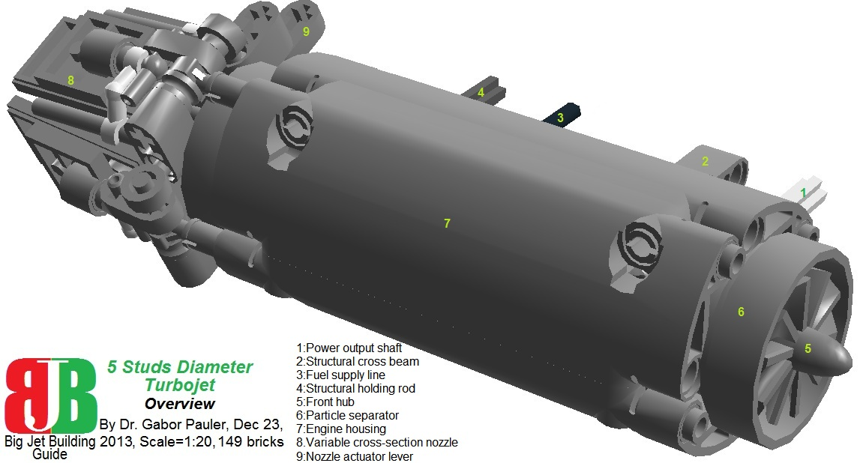
<b>Figure 32: Overview of 5 studs-diameter turbojet </b>

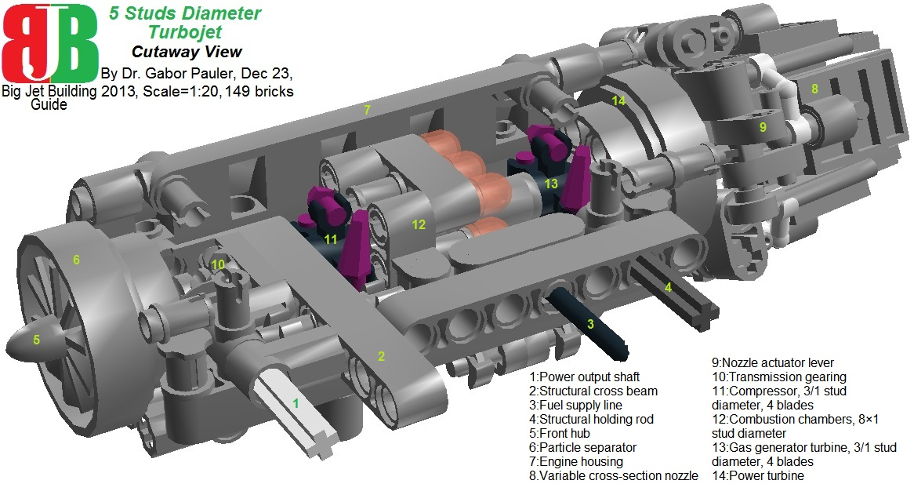
<b>Figure 33: Cutaway view of 5 studs-diameter turbojet </b>

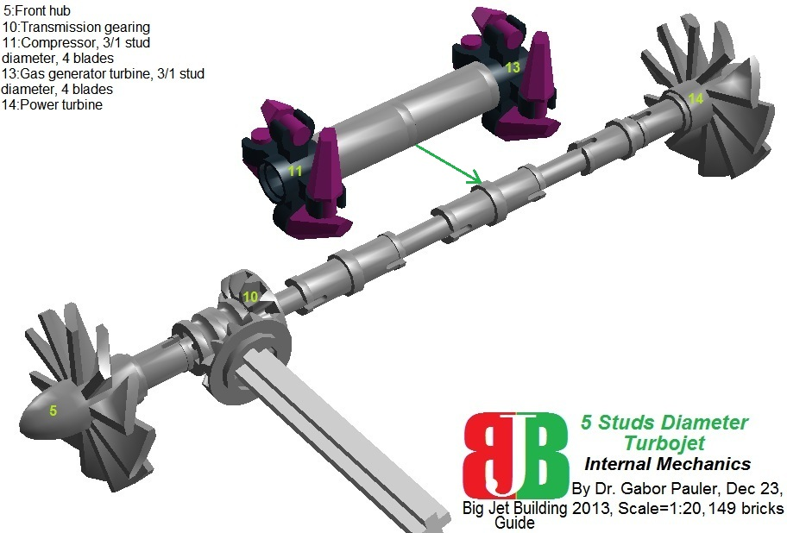
<b>Figure 34: Internal mechanics of 5 studs-diameter turbojet </b>
See model in LDD: <a href=http://www.brickshelf.com/gallery/gjpauler/JetEngine/smallturbojet.lxf>Here</a>

<b><u>4.2. 5 studs-diameter turboshaft</b></u>

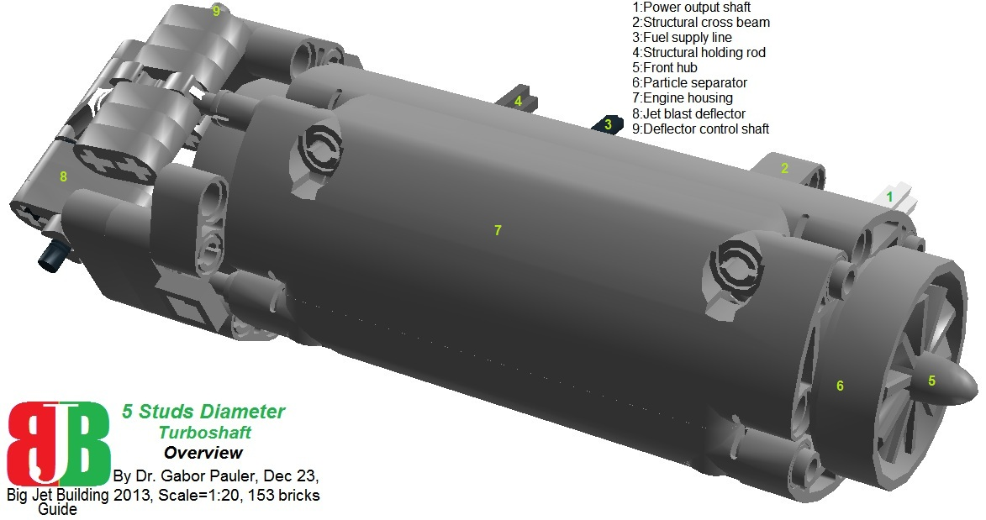
<b>Figure 35: Overview of 5 studs-diameter turboshaft </b>

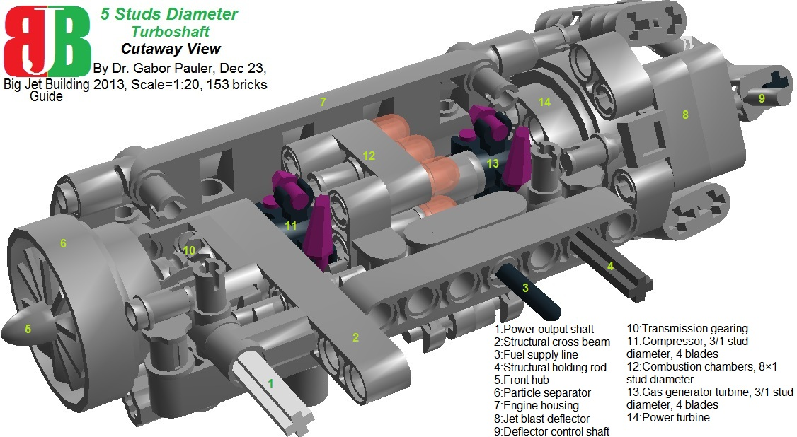
<b>Figure 36: Cutaway view of 5 studs-diameter turboshaft </b>

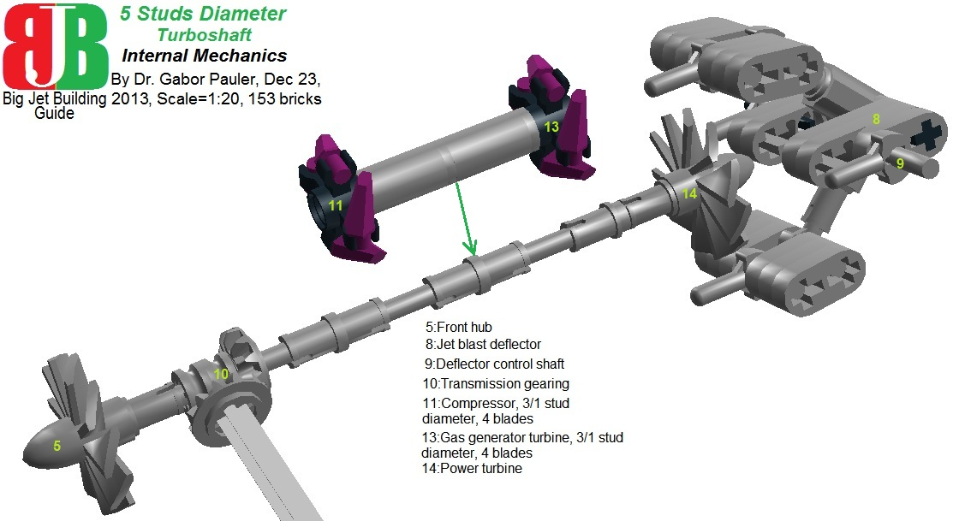
<b>Figure 37: Internal mechanics of 5 studs-diameter turboshaft </b>
See model in LDD: <a href=http://www.brickshelf.com/gallery/gjpauler/JetEngine/smallturboshaft.lxf>Here</a>

<b><u>4.2. 5 studs-diameter short turboshaft</b></u>

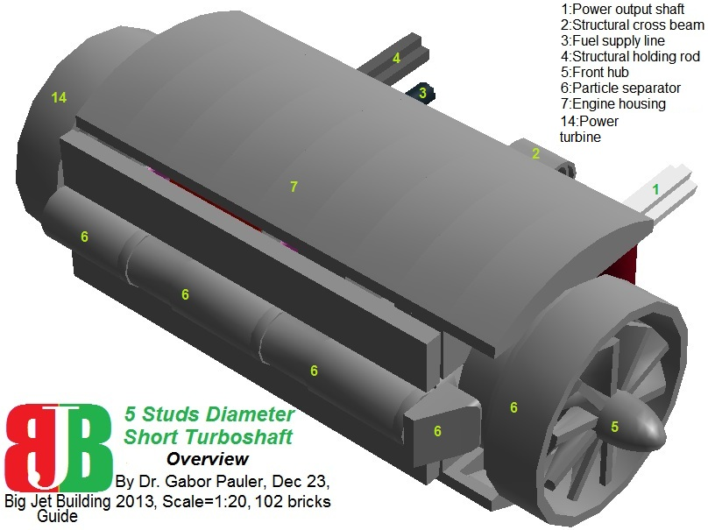
<b>Figure 38: Overview of 5 studs-diameter short turboshaft </b>

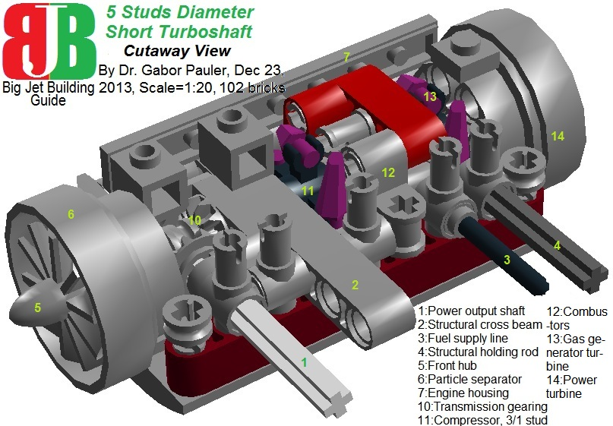
<b>Figure 39: Cutaway view of 5 studs-diameter short turboshaft </b>

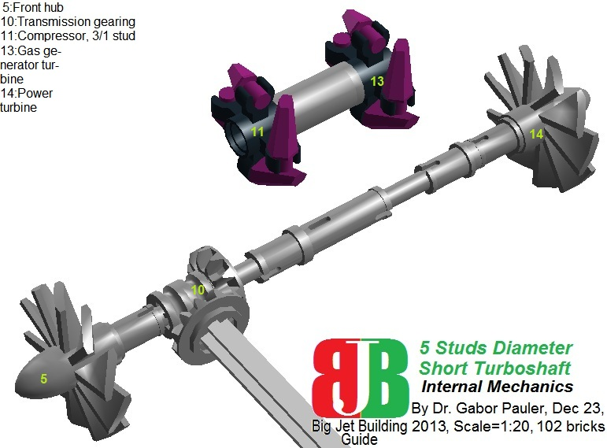
<b>Figure 40: Internal mechanics of 5 studs-diameter short turboshaft </b>
See model in LDD: <a href=http://www.brickshelf.com/gallery/gjpauler/JetEngine/miniturboshaft.lxf>Here</a>

<b><u>4.4. 7/5 studs-diameter turbofan</b></u>

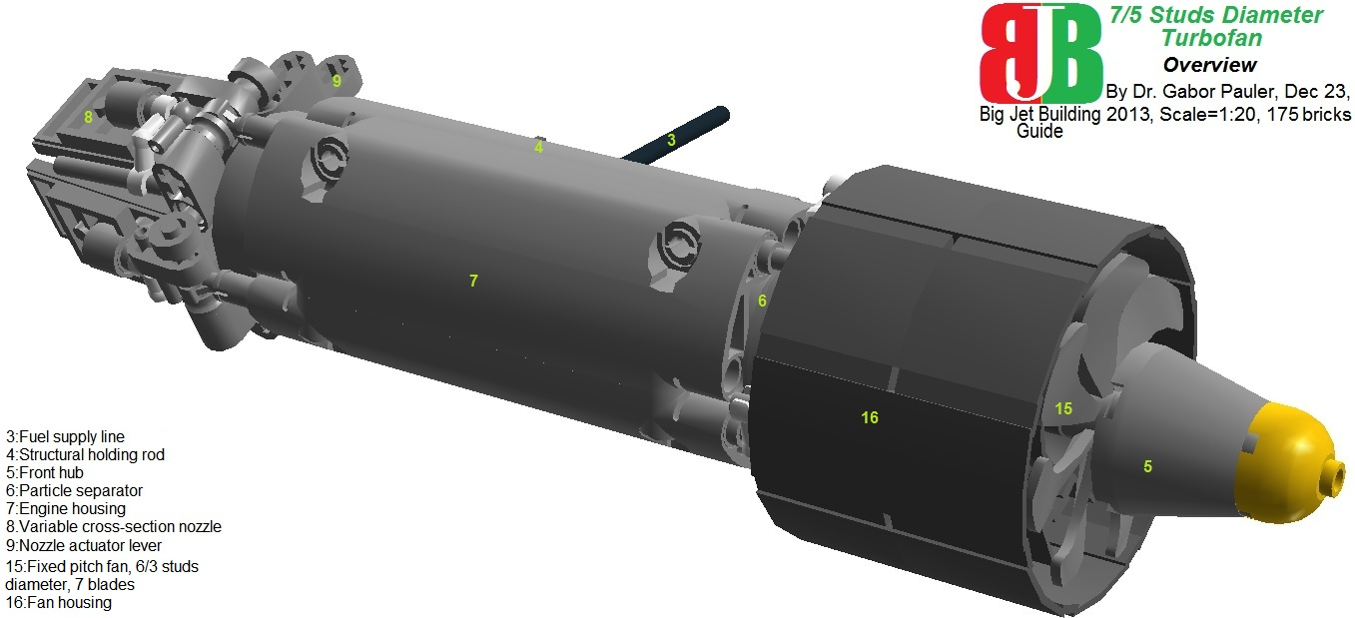
<b>Figure 41: Overview of 7/5 studs-diameter turbofan </b>

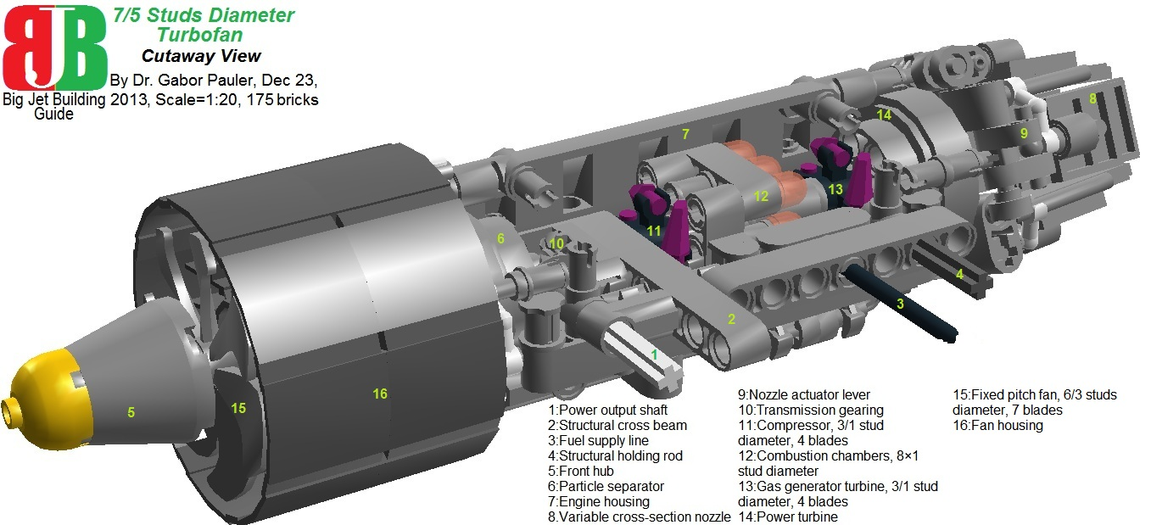
<b>Figure 42: Cutaway view of 7/5 studs-diameter turbofan </b>

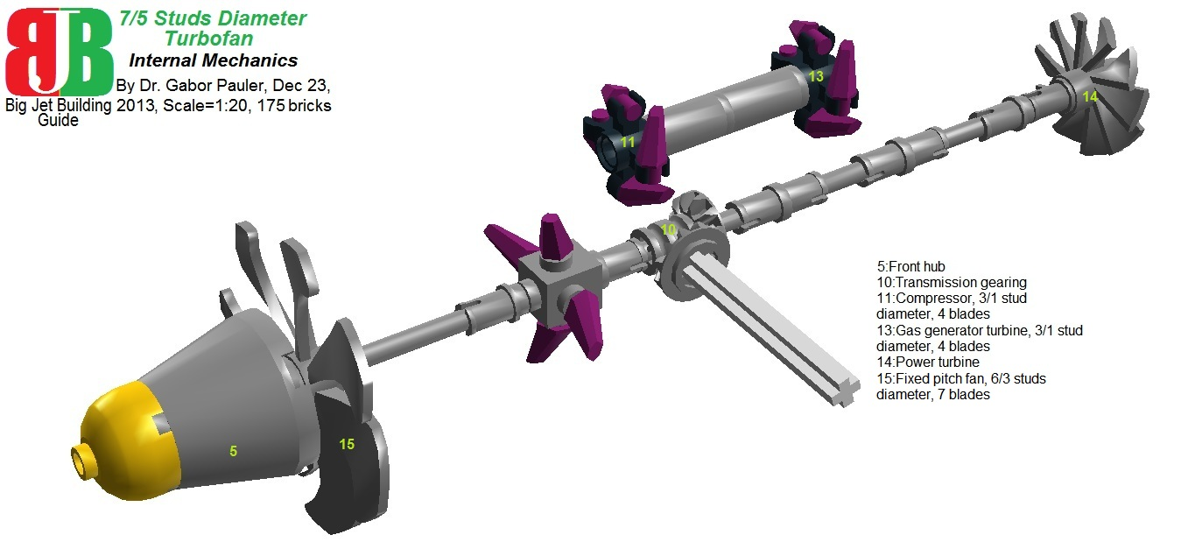
<b>Figure 43: Internal mechanics of 7/5 studs-diameter turbofan </b>
See model in LDD: <a href=http://www.brickshelf.com/gallery/gjpauler/JetEngine/smallturbofan.lxf>Here</a>

<big><b><u>5.Family of 3 studs-diameter jet engines</b></u></big>

This family of engines can be used as medium engines in 1:38 minifig scale. There is not much sense in trying to build functional engines in such a small scale, but the modeling challenge was there: what we can put together in the scale of the original TLG jet engine parts. Due lack of space, we lost further functions compared to previous engine family:
- Power output shaft is gone, except the turboshaft engine.
- Nozzle is not controllable anymore and rotates together with power turbine.
- Housing of fixed pitch fan at turbofan rotates together with main shaft.
- Structural rigidity is gone, as engine housing in this small size could only be solved from 8 parts ‘Grease band element’.
- There are only 1 combustor head in these engines due lack of space.
- All compressors and turbines are based on part ‘Hub 17mm with spokes’. Its spokes have no pitch at all, but in such a small size, still this part resembles the most to a compressor/turbine stage.
But, we still retained moving parts and realistic airflow inside these engines.

<b><u>5.1. 3 studs-diameter turbojet</b></u>

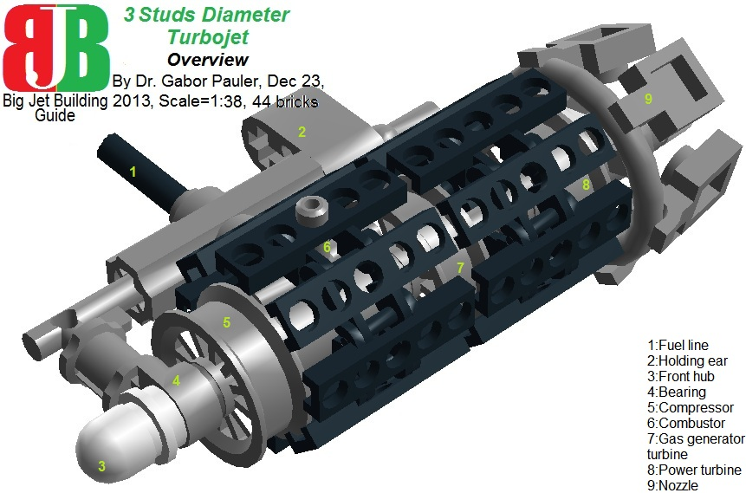
<b>Figure 44: Overview of 3 studs-diameter turbojet </b>

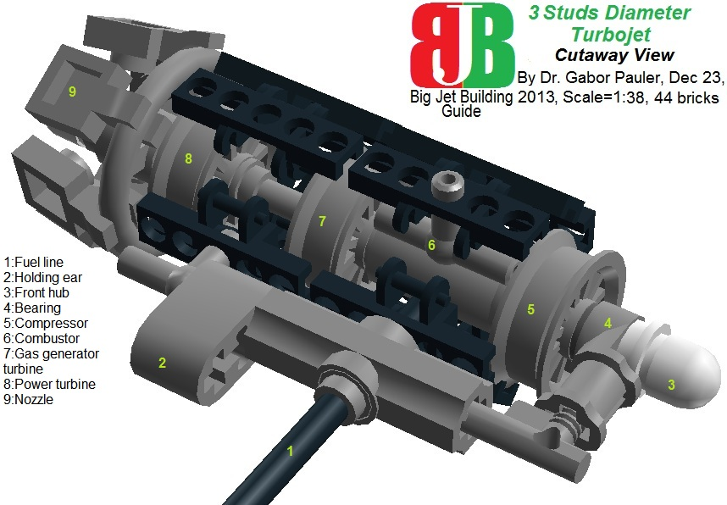
<b>Figure 45: Cutaway view of 3 studs-diameter turbojet </b>

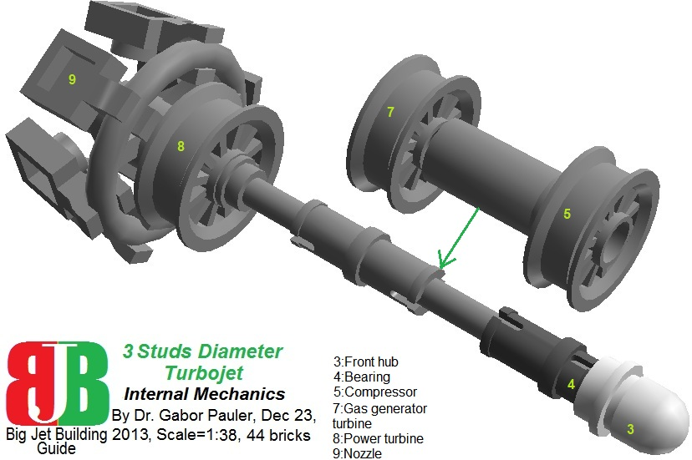
<b>Figure 46: Internal mechanics of 3 studs-diameter turbojet </b>
See model in LDD: <a href=http://www.brickshelf.com/gallery/gjpauler/JetEngine/microturbojet.lxf>Here</a>

<b><u>5.2. 3 studs-diameter turboshaft</b></u>

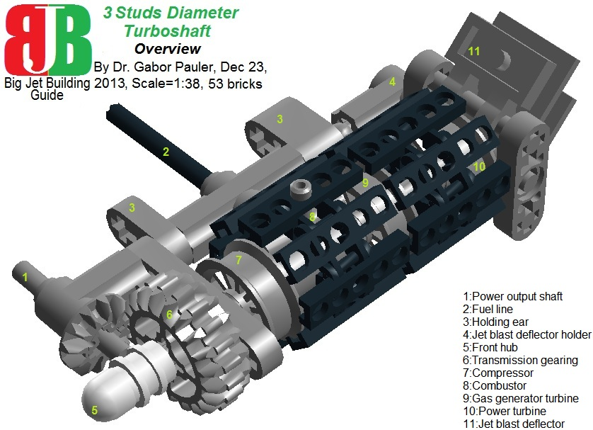
<b>Figure 47: Overview of 3 studs-diameter turboshaft </b>

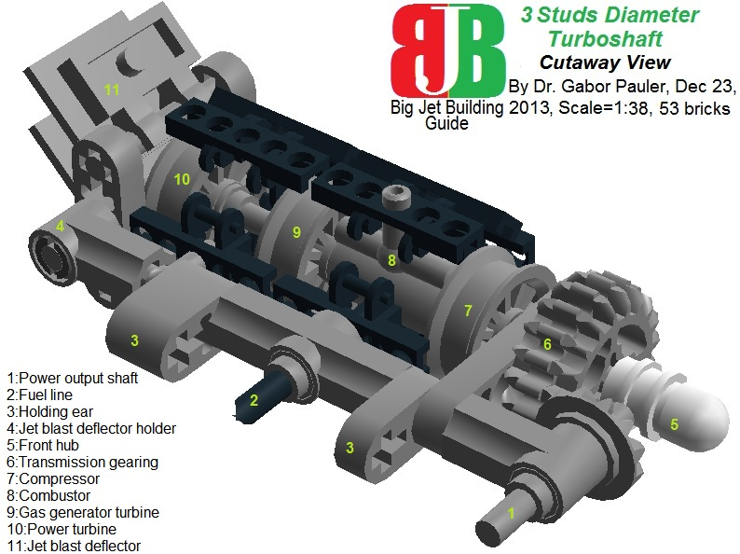
<b>Figure 48: Cutaway view of 3 studs-diameter turboshaft </b>

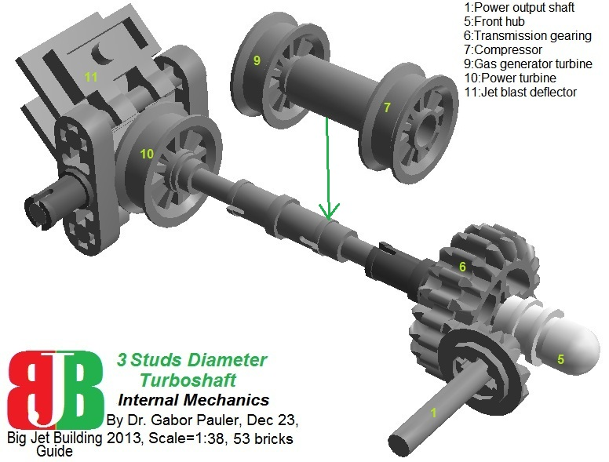
<b>Figure 49: Internal mechanics of 3 studs-diameter turboshaft </b>
See model in LDD: <a href=http://www.brickshelf.com/gallery/gjpauler/JetEngine/microturboshaft.lxf>Here</a>

<b><u>5.3. 4/3 studs-diameter turbofan</b></u>

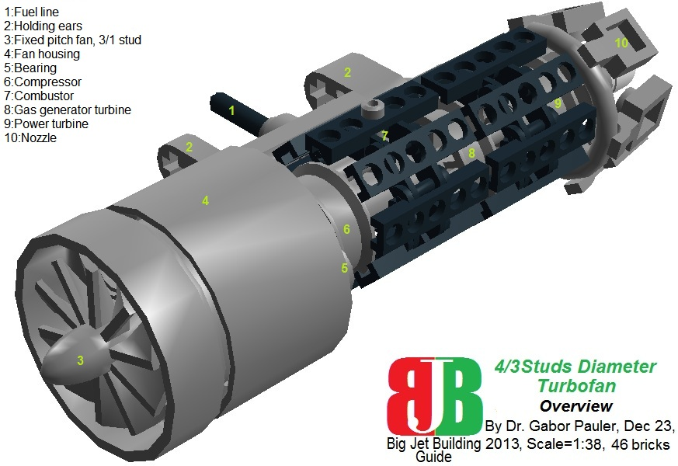
<b>Figure 50: Overview of 4/3 studs-diameter turbofan </b>

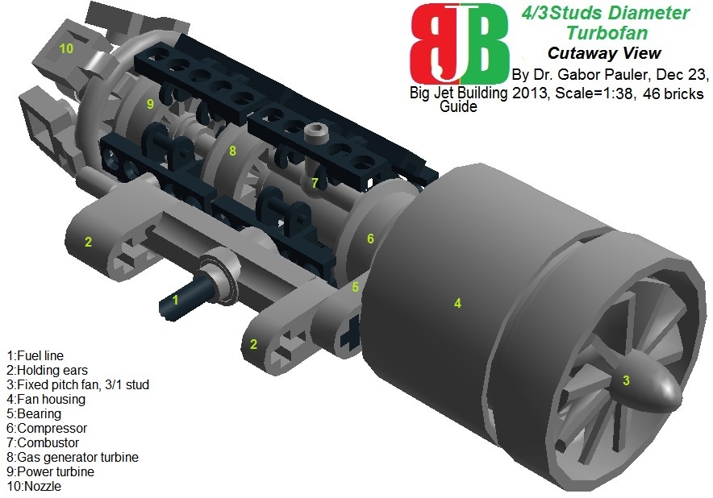
<b>Figure 51: Cutaway view of 4/3 studs-diameter turbofan </b>

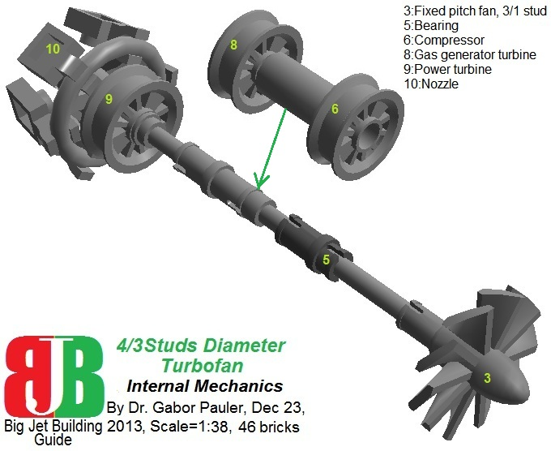
<b>Figure 52: Internal mechanics of 4/3 studs-diameter turbofan </b>
See model in LDD: <a href=http://www.brickshelf.com/gallery/gjpauler/JetEngine/microturbofan.lxf>Here</a>

Building all these engines, we gained lot of experience about general engine building techniques what we share with you in the following chapter.

<big><b><u>6.Basic building tricks of jet engines</b></u></big>

<b><u>6.1. Compressor/power turbine rotors from 2 studs to 9 studs diameter</b></u>
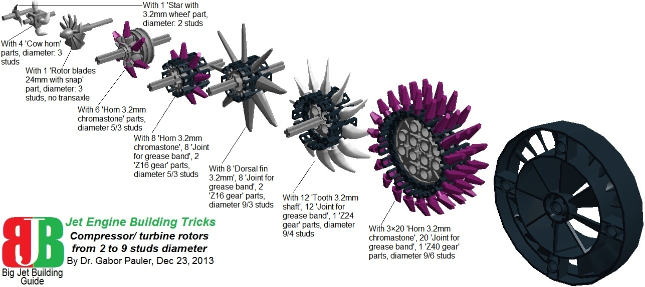
<b>Figure 53: Overview of Compressor/power turbine rotors </b>
See model in LDD: <a href=http://www.brickshelf.com/gallery/gjpauler/JetEngine/TurbineRotors.lxf>Here</a>

As the largest usable turbine rotor in TLG parts has a diameter of 3 studs (the 10 stud TLG turbine part has pointless design flaws), and cannot handle transversal axles, its usability is limited. There are two keys for building large diameter turbine rotors:
1. Parts ‘Joint for grease band’ connected into 8/ 12/ 20 element long tracks can be rolled around Z16, Z24, Z40 gears. In each joint, there are 5 holes for 3.2mm shafts, where the middle hole lets trough the shaft, while the others hold it 0.25 studs (2mm) deep. This way they can serve as 8/ 12/ 20 spoke hubs, adding 1 extra studs to the original diameter of the central gear.
2. There are 3 turbine/ compressor blade like parts, which you can stick in that holes:
- ‘Horn 3.2mm chromastone’ – creates 1 stud long blade
- ‘Tooth 3.2mm shaft’ – creates 2.5 studs long blade
- ‘Dorsal fin 3.2mm’ – creates 3 studs long blade
Using this technique, the smallest rotor you can build has 5 studs diameter (Z16 gear + 8 joints + 8 horns), and the largest has 12 studs (Z40 gear + 20 joints + 20 dorsal fins), and diameters 6, 8, 9, 10, 11 studs are also achievable, creating quite a selection. The hardest limitation of the method is the 3 stud length of track joints eating up lot of space in the engine. But different diameter hubs can be partially nested into each other, so multi-stage turbine assemblies have 3+2+2+… studs length.

<b><u>6.2. High pressure compressors/gas generator turbines from 3 studs to 9 studs diameter</b></u>
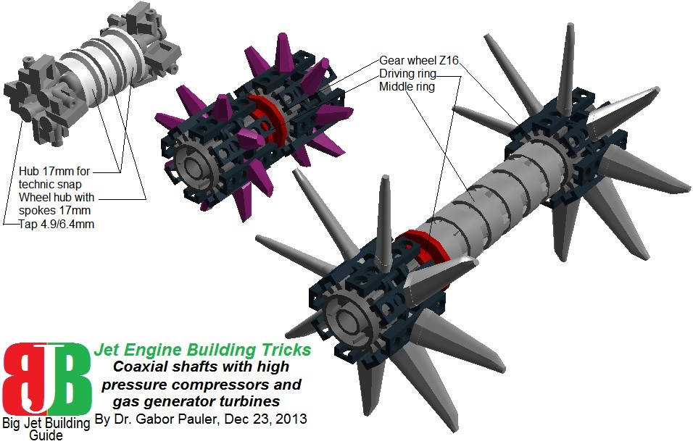
<b>Figure 54: Overview of High pressure compressors/gas generator turbines </b>
See model in LDD: <a href=http://www.brickshelf.com/gallery/gjpauler/JetEngine/RunningGears.lxf>Here</a>

In most types of jet engines (turboshaft, turboprop, turbofan) there are coaxial main shafts to separate high rpm, high pressure compressor stages and gas generator turbines from low rpm, low pressure compressor stages and power turbines. One basic shortcoming of Technic is the almost complete lack of coaxial tube shaft-like parts. Therefore, coaxial shafts are made from Technic gear shift parts: pair of ‘Gear wheel Z16’ parts support each compressor/ turbine rotors, and driving- and middle rings connect them, running freely on main shaft.

<b><u>6.3. Variable pitch fans from 10 studs to 13 studs diameter</b></u>
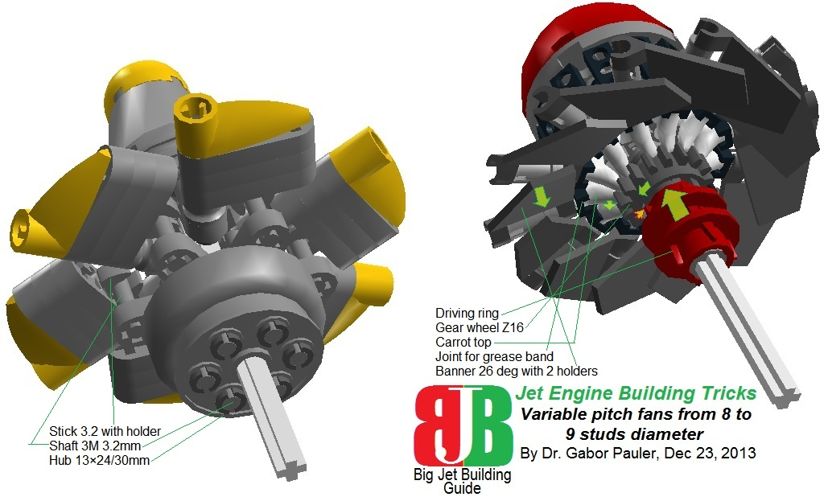
<b>Figure 55: Overview of Variable pitch fans </b>
See model in LDD: <a href=http://www.brickshelf.com/gallery/gjpauler/JetEngine/VariablePitchFans.lxf>Here</a>

Large scale turbofans require large diameter, multi-blade fans, which can exceed 12 studs diameter we can build using our turbine rotor building technique. Moreover, they should be variable pitch fans to enable reverse thrust engine braking at landing of conventional aircrafts, or differential pitch yaw/roll control in VTOL crafts using multiple lift fans. (Against Hollywood movies and small quadcopters, it is tried and proven that the more simple differential fan rpm control is not enough fast and responsive at large VTOL crafts to achieve yaw/roll stability). We developed two models for variable pitch fan:
- The 6-blade unit is aerodynamically inferior, but mechanically more strong and can be set to negative/zero/positive pitch with the help of ‘Hub 13×24/30mm’ acting as rotating driving ring, which can slide 0.5 studs forward/backward on main shaft. The diameter of this unit can be varied freely from 8 studs to 19 studs.
- The 12-blade unit is aerodynamically more advanced, but mechanically more weak construction. It can be set only to zero or positive pitch (no reverse thrust braking). Moreover its diameter can be only 8 studs. Its operating principle bases on that when Lego Technic gear shift part ‘Driving ring’ is pushed into ‘Gear wheel Z16’, and catches it by its hooks, it will rotate the gear wheel some degrees relative to the driving ring. (Driving ring can slide on main shaft, but cannot rotate on that). Rotating gear wheel turns 16 ‘Carrot top’ parts placed radially in the holes of the ‘Z24 gear + 12 track joints’-style hub, because left branches of carrot tops are hooked among the teeth of the gear wheel. Carrot tops act as pitch axles of the 12 turbine blades made from ‘Banner 26 deg with 2 holders’ parts.

<b><u>6.4. Variable pitch propellers from 13 studs to 21 studs diameter</b></u>
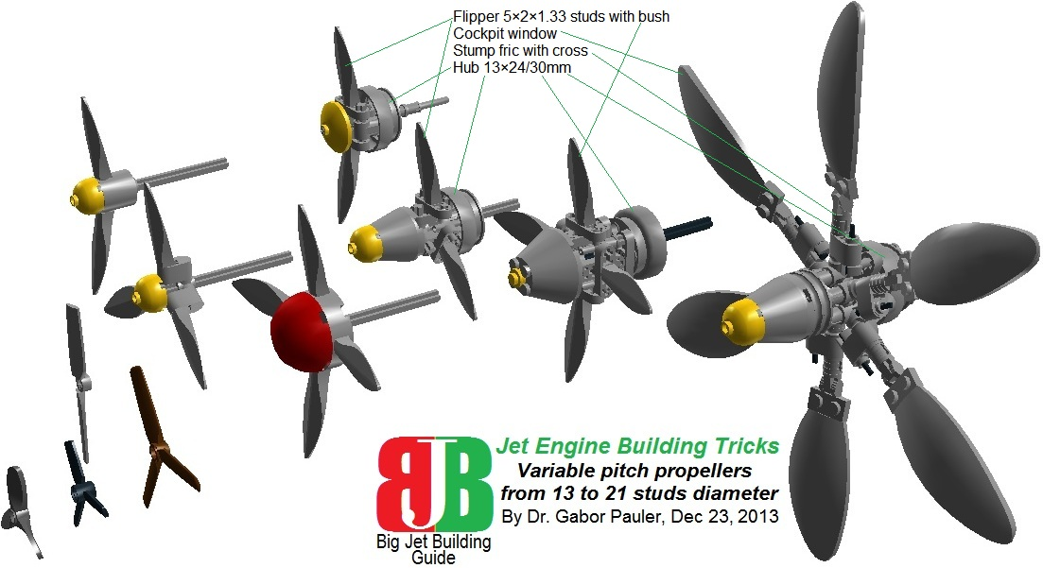
<b>Figure 56: Overview of Variable pitch propellers </b>
See model in LDD: <a href=http://www.brickshelf.com/gallery/gjpauler/JetEngine/VariablePitchPropellers.lxf>Here</a>

For modeling modern turboprop engines, we need propellers. Moreover, we need variable pitch propellers. More-moreover, we need efficient low rpm, multi-blade, wide-bladed propellers. TLG propeller parts are smallish even in 1:38 minifig scale (6 studs maximum diameter and max. 3 blades). So you cannot just stick the good old 4-blade Hamilton Standard Hydromatic as one part on your minifig B-29 model. Some MOCers solve this using smooth 6×1 or 8×1 studs tiles as blades, but that’s just too boxy for a nicely faired SNOT aircraft. Others commit drug abuse in their desperation using Megabloks propellers. The creeping use of all kinds of Megabloks key aircraft parts (cockpit canopies, propellers, nose cones, landing gears, etc.) on high-end aircraft MOCs shows that just how stone-headed are TLG part designers. Creative guys try to do something about prop shortage. I vividly remember a B-17 model with props made of part ‘Ice cream’. It was not as bad as it sounds. Our secret weapons in the prop story are parts ‘Flipper 5×2×1.33studs with bush’ and non-transparent version of ‘Cockpit window’. Using them we developed 2, 3, 4 bladed variable pitch props with 13 studs diameter for scale 1:20, and 2, 3 or 6 bladed unit with 21 studs diameter for scale 1:10. All of them use ‘Hub 13×24/30mm’ part as driving ring sliding on propeller shaft forward/backward for pitch control.

<b><u>6.5. Variable cross-section nozzle cones from 4 studs to 11 studs diameter</b></u>
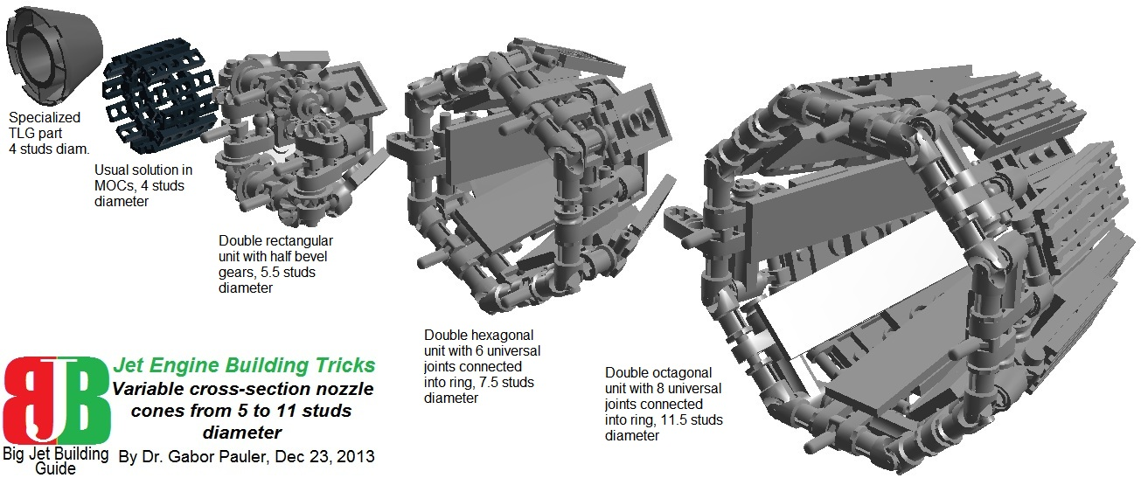
<b>Figure 57: Overview of Variable cross-section nozzles </b>
See model in LDD: <a href=http://www.brickshelf.com/gallery/gjpauler/JetEngine/VariableCrossSectionNozzles.lxf>Here</a>
Variable cross-section nozzle cones of jet engines are another critical issue in Lego often leading desperate MOCers into Megabloks abuse. The specialized TLG part has 4 studs diameter, and models cone in rather primitive way. At high-end jet MOCs, the usual solution is a ring made of 12 ‘Joint for grease band’ parts. It looks nice, but it is totally dysfunctional. In my best knowledge, nobody tried working variable cross-section nozzle cone in Lego yet. My therapist was on a holiday, so I tried to do it, making some reasonable compromise between form and functionality. The basic idea is connecting 6 or 8 ‘Universal joint’ parts into hexagonal/ octagonal rings with 3 stud shafts, and branching partially overlapping nozzle flaps from them. The ring is fixed to the back side of engine housing with parts ‘Stick 3.2mm with holder’ parts, which allow its shafts to rotate, closing together/opening the overlapping flaps. Hexagonal unit has 7.5 studs diameter and best fits to scale 1:20. Octagonal unit has 11.5 studs diameter and best fits to scale 1:10. I tried to do it also for scale 1:38 with 5 studs diameter. It was too small for using universal joints, so I opted for rectangular aligned 3-stud shafts coupled with four pairs of half bevel gears. But this solution is inferior compared to larger units both in look and working.

<b><u>6.6. Combustion chamber units from 5 studs to 11 studs diameter</b></u>
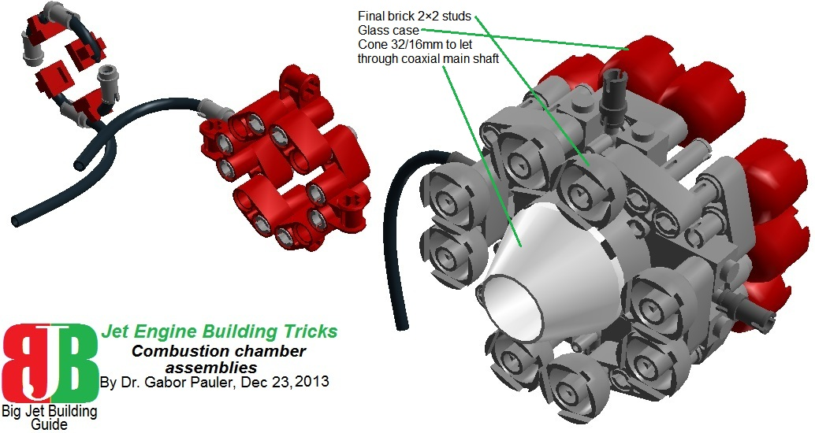
<b>Figure 58: Overview of Combustion chambers </b>
See model in LDD: <a href=http://www.brickshelf.com/gallery/gjpauler/JetEngine/Combustors.lxf>Here</a>

Combustion chambers are modeled with incoming fuel supply line. They are fixed to the engine housing from inside, and have a hole in the middle, letting through coaxial main shaft of the engine.

<b><u>6.7. Particle separators</b></u>
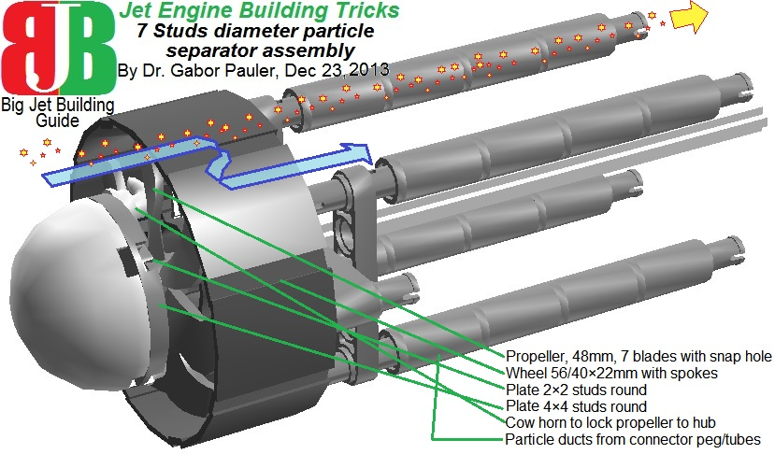
<b>Figure 59: Overview of Particle separator </b>
See model in LDD: <a href=http://www.brickshelf.com/gallery/gjpauler/JetEngine/ParticleSeparator.lxf>Here</a>

The centrifugal type particle separator is mainly used in helicopter engines. It prevents dust and particles sucked in to enter into compressor and destroy that. Spun-up particles fly into particle ducts driven by their centrifugal force, bypassing the engine. While most of the clean air enters into the compressor. This feature is created with the help of parts ‘Propeller 48mm with snap’ and ‘Wheel 56×22mm with spokes’ serving as a trap for particles.

<b><u>6.8. Afterburners</b></u>
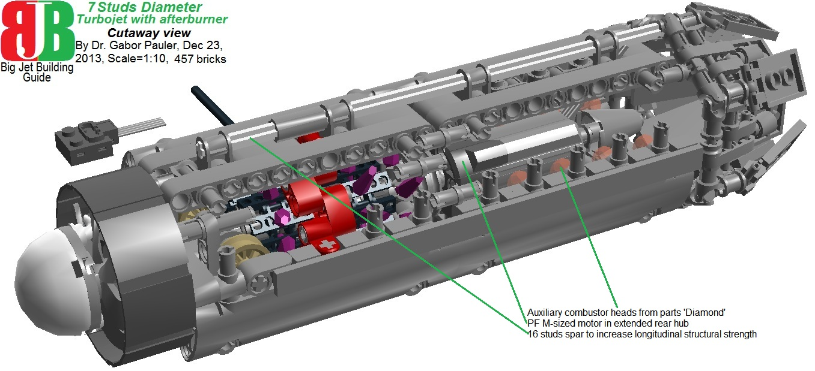
<b>Figure 60: Cutaway view of 7 studs-diameter turbojet with afterburner </b>
See model in LDD: <a href=http://www.brickshelf.com/gallery/gjpauler/JetEngine/TurboJetAfterBurning.lxf>Here</a>

Afterburners are extra fuel injectors aft to the power turbine, combusting fuel in the excess air the engine delivers. They can almost double engine thrust for a short period at the price of enormous fuel consumption and overheating. We show an example here how our 7-studs diameter turbojet was lengthened to accommodate afterburner. This way, internal electric drive can be also accommodated in extended rear hub.

<b><u>6.9. Jet blast deflectors</b></u>
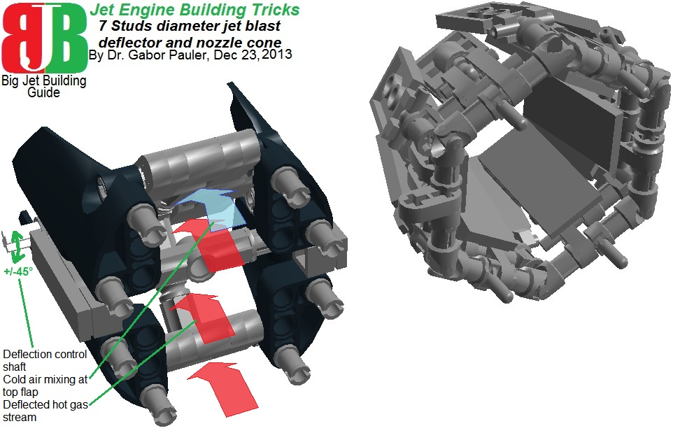
<b>Figure 61: Comparison of jet blast deflector and variable cross section nozzle </b>
See model in LDD: <a href=http://www.brickshelf.com/gallery/gjpauler/JetEngine/JetBlastDeflector.lxf>Here</a>

The jet blast deflector can be adjusted with a control shaft to deflect jet blast from -45 degrees to +45 degrees from horizontal, and allowing it to mix with cold air through an opening flap (see the blue and red arrows at Figure 43). This is a usual solution at turboshafts of most battlefield helicopters to prevent enemy IR-homing missiles to capture heat signal of the engine. To make it easier understandable, we prepared a demo model of twin turbofans (see Figure 44). One of them is equipped with nozzle, the other one with jet blast deflector. You can see what the IR-sensor of an incoming Sidewinder missile can see. Jet engines are surprisingly “transparent” from the back side compared to piston engines. Modern AIMs have 256×256 pixel Focal Pane Array IR-sensor made of Indium Sulfide semiconductors. Pre-cooling of IR-head of the missile with liquefied high pressure Nitrogen stored in a bottle in the launching pod makes it even more sensitive. So the missile can see blades rotating aft combustion chambers as very distinctive IR-signal.

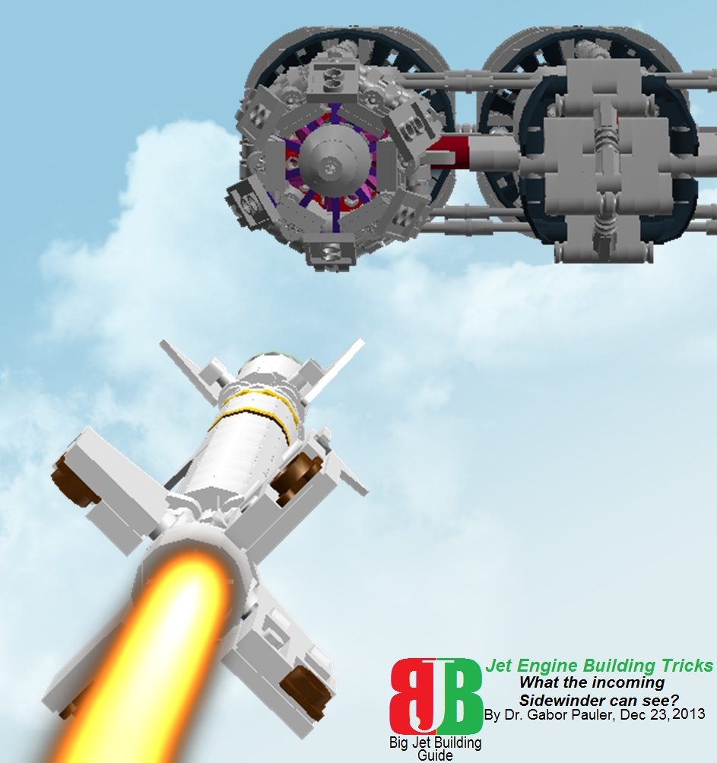
<b>Figure 62: What the incoming Sidewinder missile can see? </b>
See model in LDD: <a href=http://www.brickshelf.com/gallery/gjpauler/JetEngine/IncomingMissile.lxf>Here</a>

<b><u>6.10. Twin engine mounts</b></u>
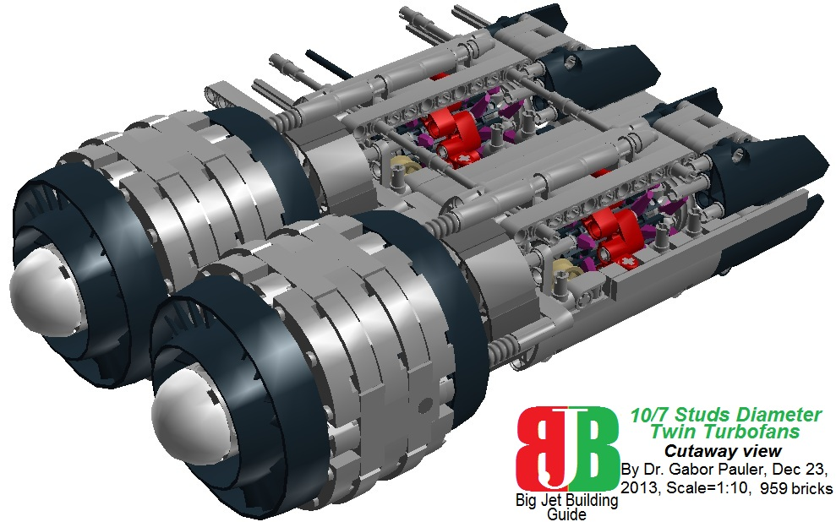
<b>Figure 63: Cutaway view of side-mounted twin turbofans </b>
See model in LDD: <a href=http://www.brickshelf.com/gallery/gjpauler/JetEngine/TurboFanShortTwin.lxf>Here</a>

Some aircraft (E.g. US B-52 bomber or Russian Iljushin IL-68 airliner) carry engines in twin nacelles. So all of our engines are constructed that way, that they can be easily twinned, connecting their power output-, fan pitch-, jet blast deflector control shafts.

<b><u>6.11. Fuel pumps</b></u>
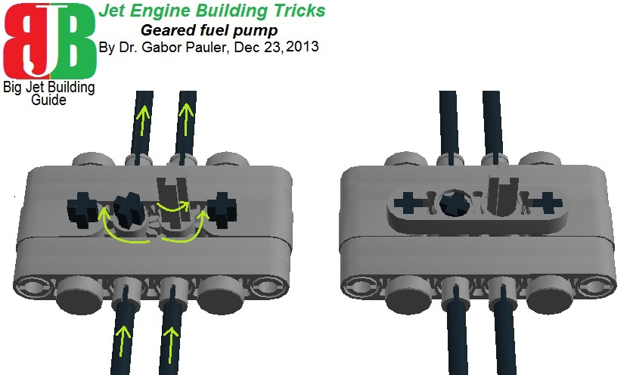
<b>Figure 64: Overview of Fuel pumps </b>
See model in LDD: <a href=http://www.brickshelf.com/gallery/gjpauler/JetEngine/FuelPump.lxf>Here</a>

We close our handbook with a simple double-geared fuel pump, which can be built in almost any Technic side walls, and can be driven by power output shaft of engines.

THE END

Let your rooftop reverberate by jet blast, our kerosene-blooded brothers.

