LEGO® MINDSTORMS® NXT

Building instructions

Brick Sorter

Robot and instructions made by Laurens

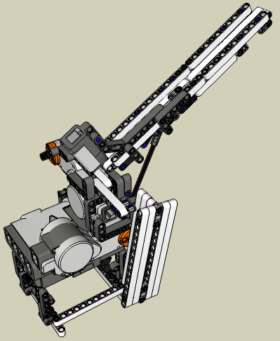
Instructions modeled using Google SketchUp

Table of contents

Table of contents 2
Building instructions 3
Base 3
Motor B 5
Motor A 6
Depositor Slide 10
Loading Chute (Part 1) 13
Loading Chute (Part 2) 18
Programming Instructions 25
The HiTechnic Color Sensor 26
How to attach it to the brick sorter 26
Programming 26
Help! – Trouble shooting 27

Building instructions

Base
04
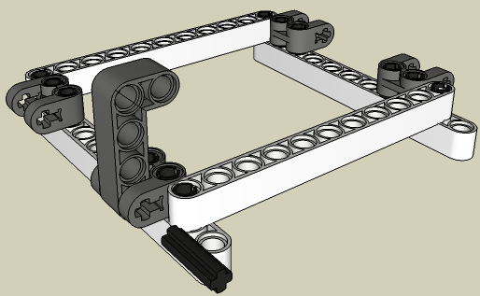
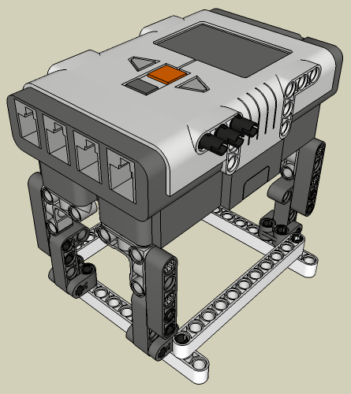
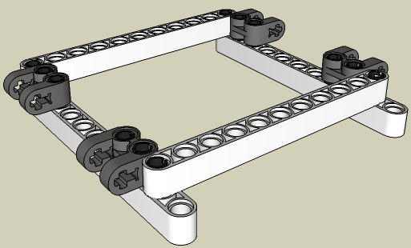
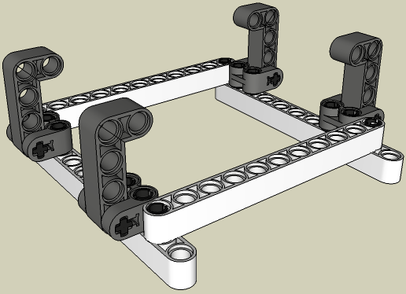
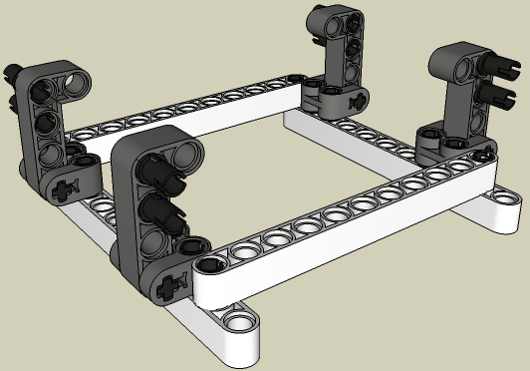
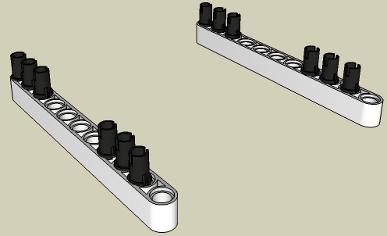
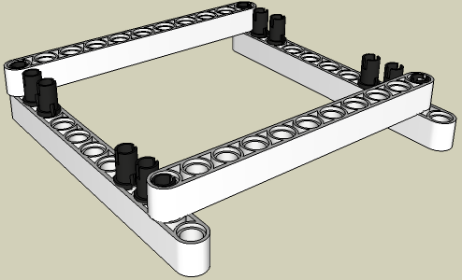

03
05
06
02
01
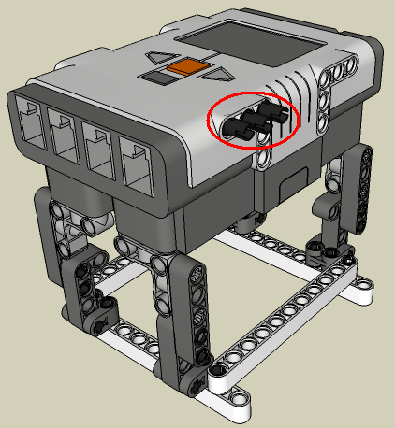
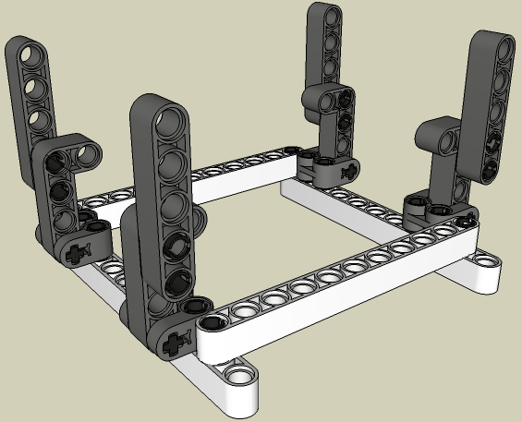
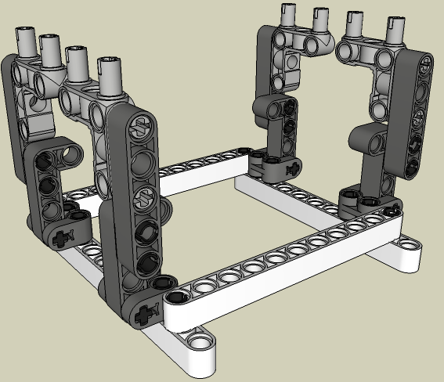
07
08
09
Motor B
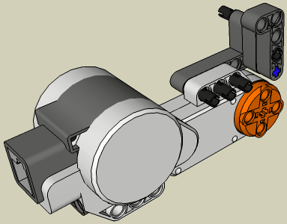
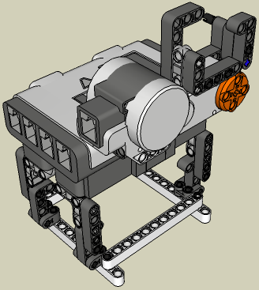

13

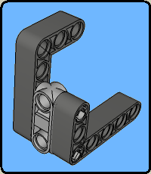

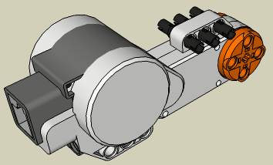
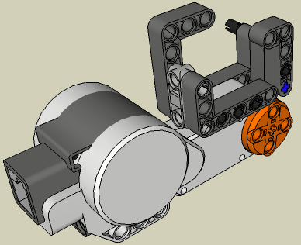
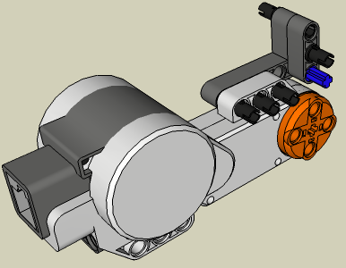
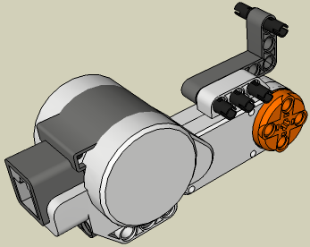

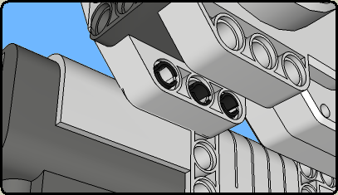
10
11
12
14
15
Motor A
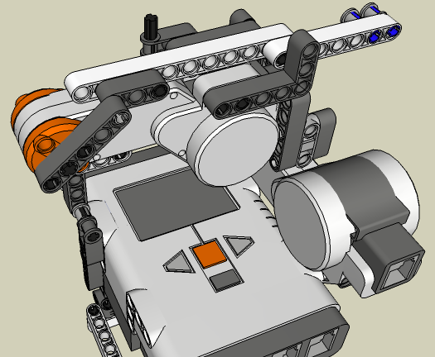
19
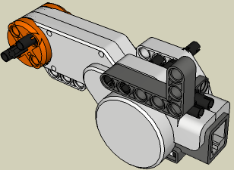

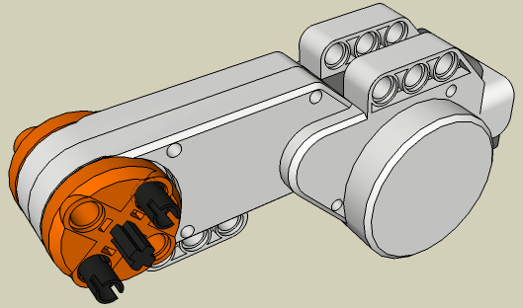
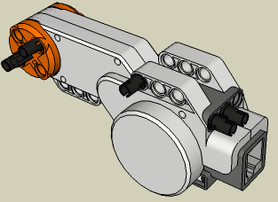
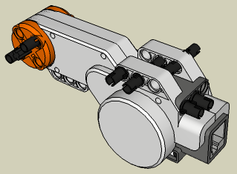
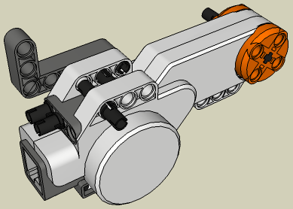
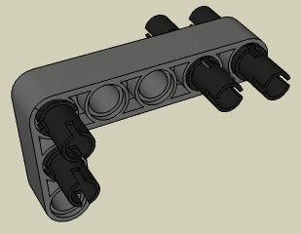
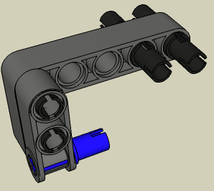
16
17
18
20
21
22
4
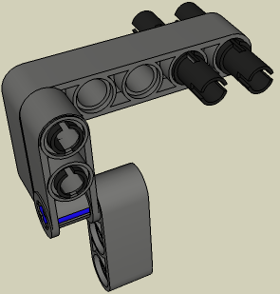
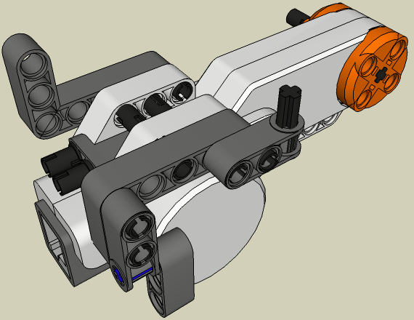
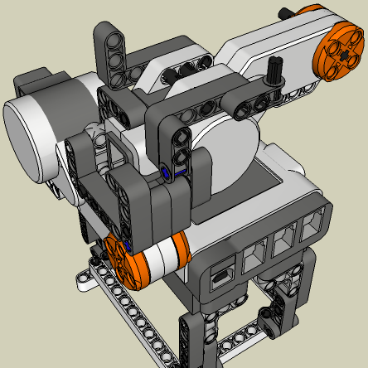
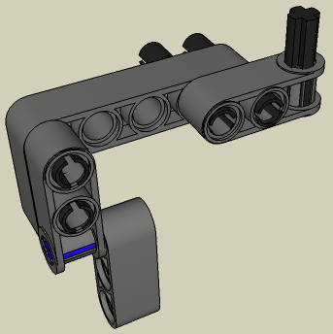
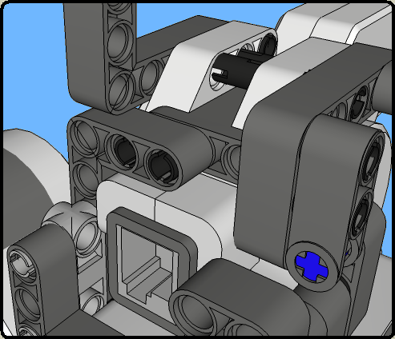
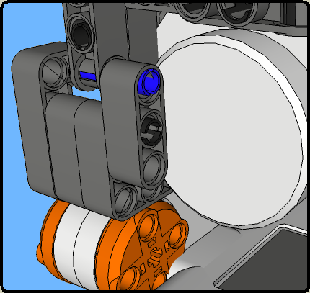
23
24
25
26
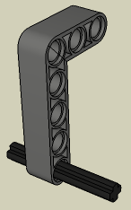
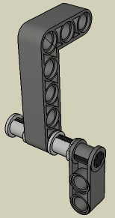
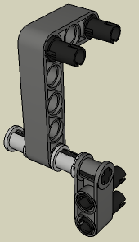
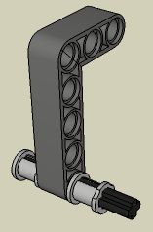
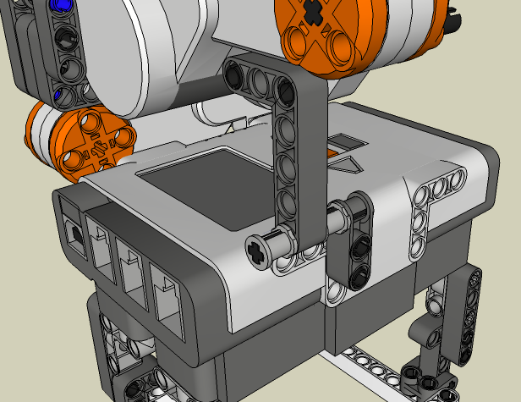
27
4
28
29
30
31
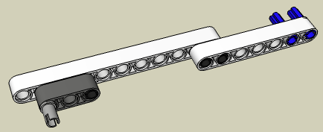
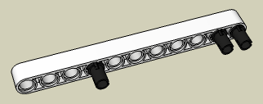
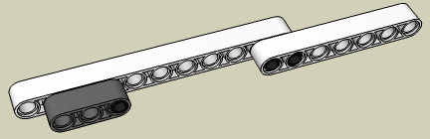

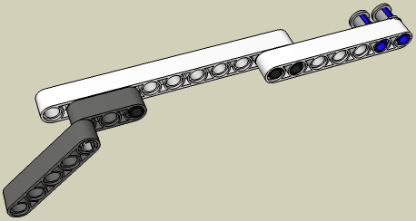
32
33
34
35
36
Depositor Slide
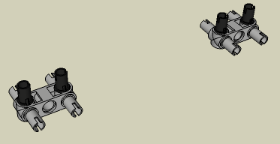
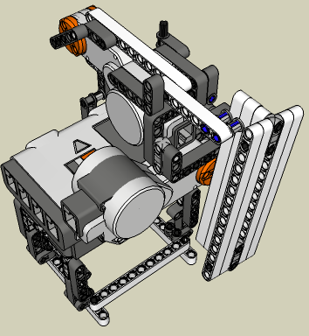
37
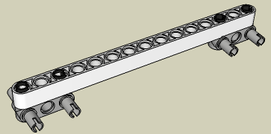
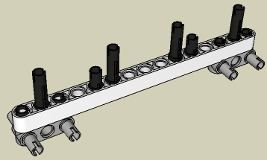
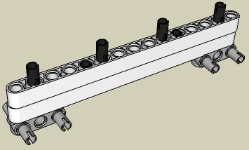
38
39
40
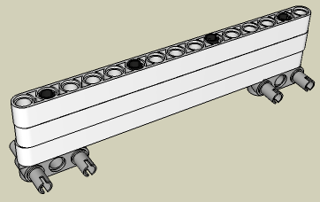
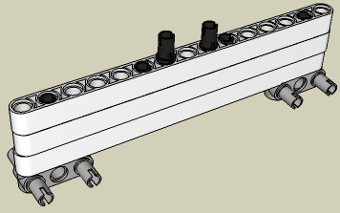
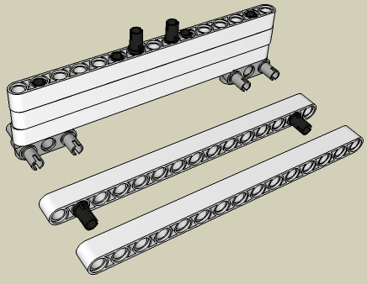
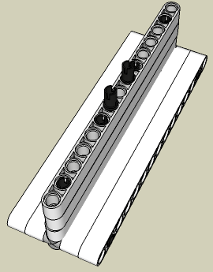
41
42
43
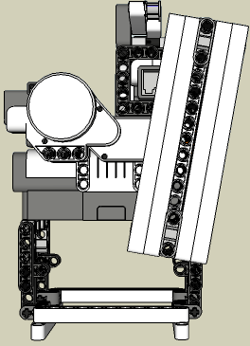
44
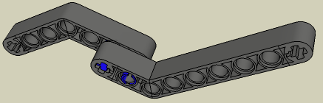
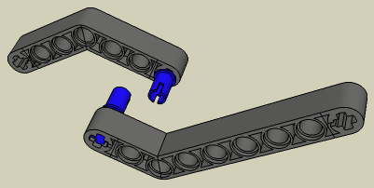
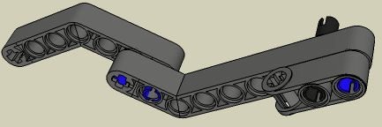
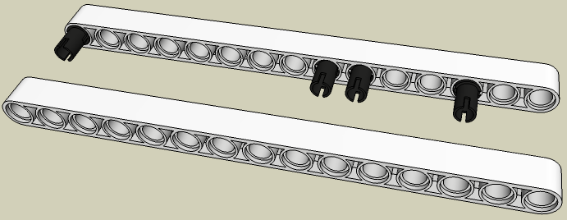
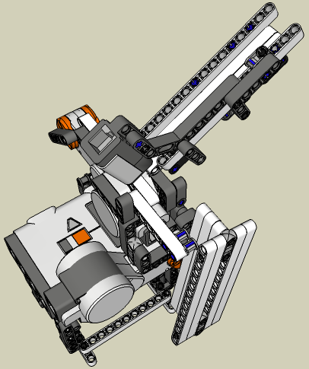
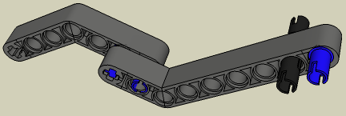
Loading Chute (Part 1)
45
46
47
48
49
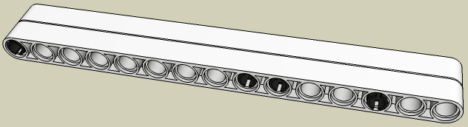
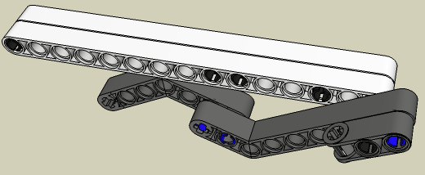
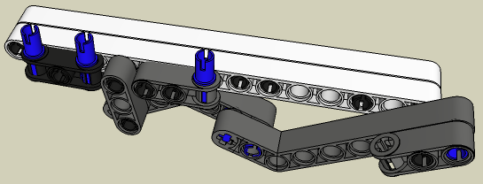
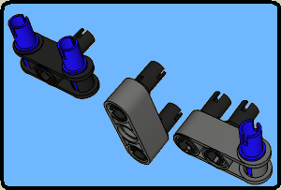
50
51
52
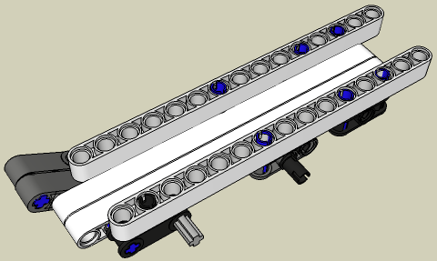
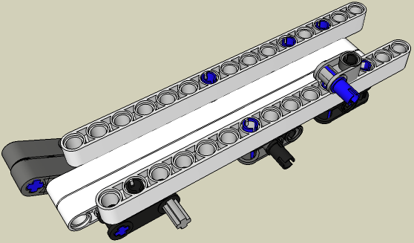
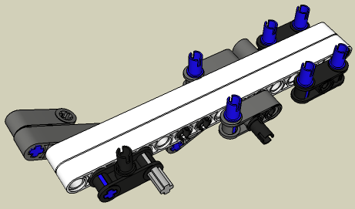
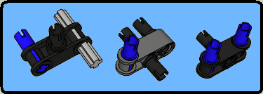
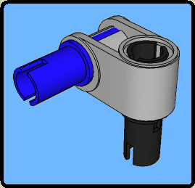
53
54
55
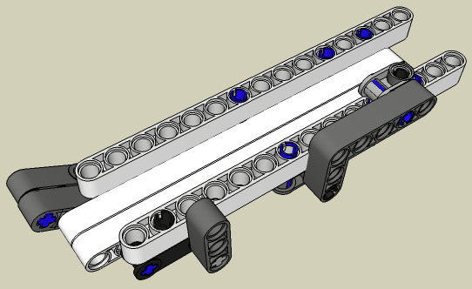
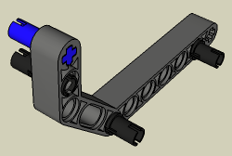
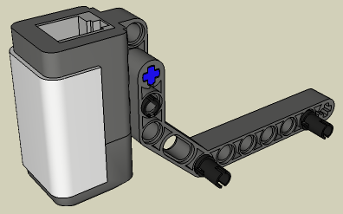

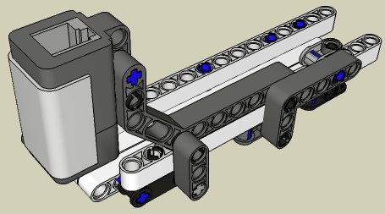
56
57
58
59
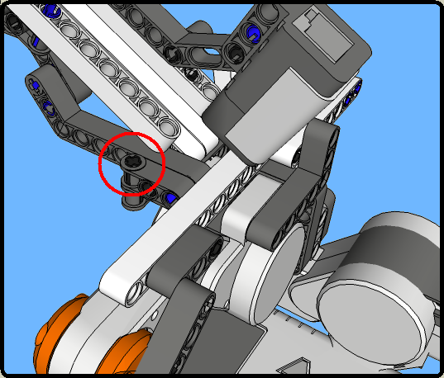
60
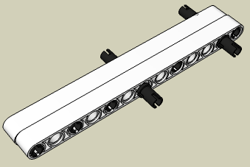
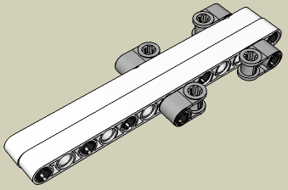
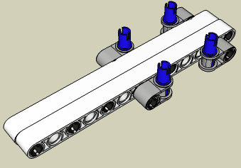
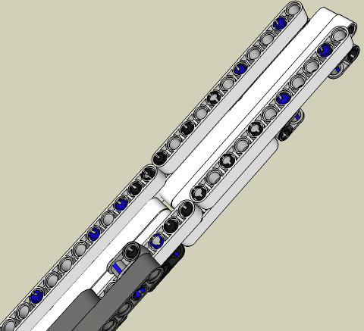
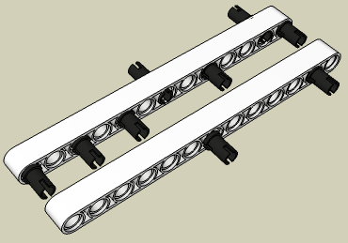
Loading Chute (Part 2)
61
62
63
64
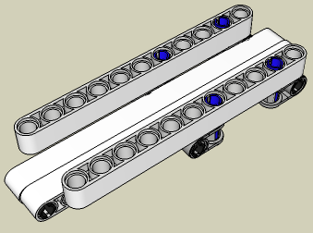
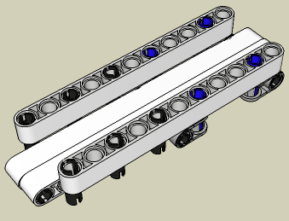
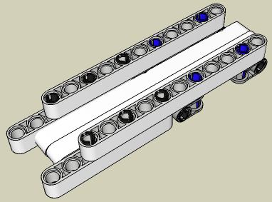
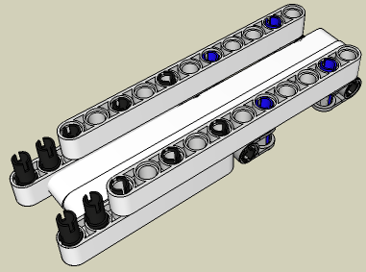
65
66
67
68
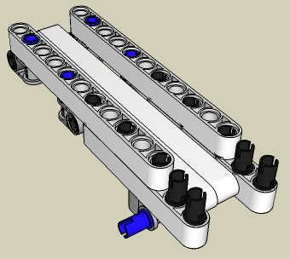

69
70
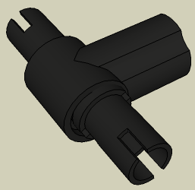
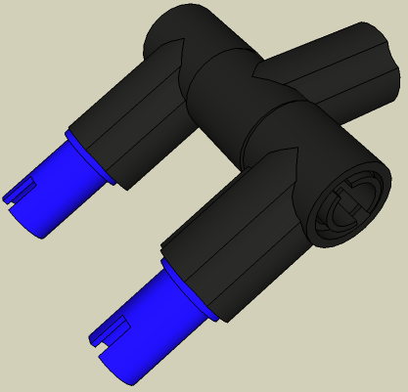
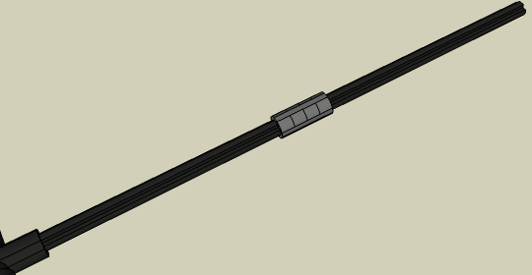

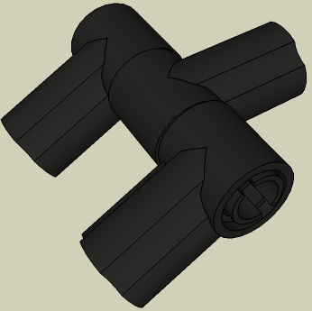
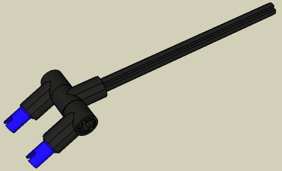
71
72
73
74
75
10
76
10
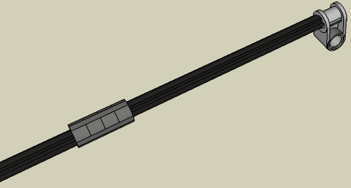
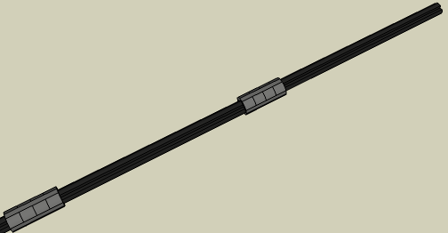
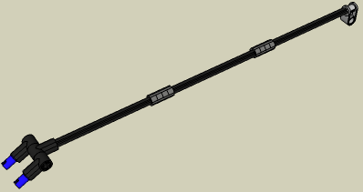
77
10
78
79
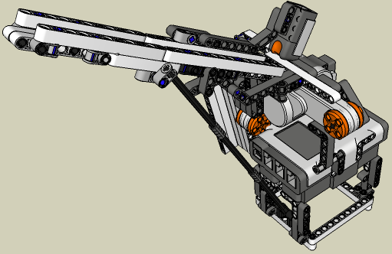
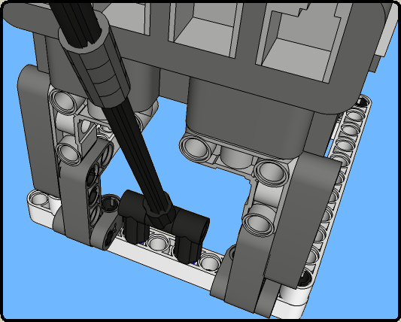
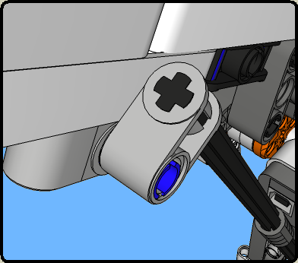
80
B
4
A
81
Programming Instructions

A downloadable program is available here: (Download)
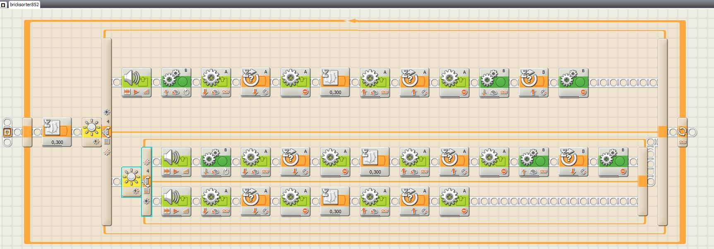
The HiTechnic Color Sensor

How to attach it to the brick sorter

58

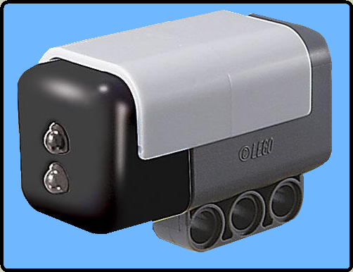
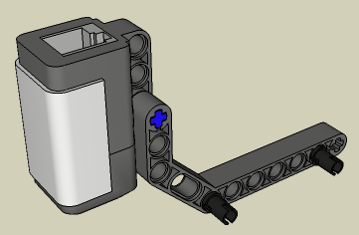
58

Programming
A downloadable program is available here: (Download)
To use this program you must install the color sensor block. This block can be found here.

Help! – Trouble shooting

Help! My brick sorter doesn’t work! Now what?!

Follow the instructions below. If you still can’t get it to work, email me at
laurens_valk [at] hotmail.com

If you don’t see the motors move at all, or only one, or if you don’t see a red light coming out of the Light sensor, start at step 1.

If the bricks get stuck while the programs runs, reference step 3.

If all above works as it should, but if the machine says ‘black’ where it should have said ‘gray’, or white, or vice versa, go to step 5

- Make sure you have downloaded the program to your brick sorter.
If you still have a problem, go to the next step.
- Make sure you have connected the cables how they should be connected, take another look at step 81 if you are not sure.
If you still have a problem, go to the next step.
- Make sure that the depositor slide is not mounted totally vertically, reference step 44, the second picture. If you still have a problem, go to the next step.
- You did put the slide in the right position, but still it doesn’t work. Take a look at this real life picture. Put the cable this way: (Click me). If you still have a problem, go to the next step.
- Finally it works, but now you are having trouble with something else, It puts some bricks in the wrong bin…
This means that there is something wrong with the program. To be a little more precise, there is something wrong with the two ‘switch blocks’ in the programs.
So, open he program. Let’s take a look at the first switch block. You will notice that if the amount of light is below 37 percent, it will say ‘black’. It will put the bricks in the bin for black bricks. But what if the gray bricks are dropped in this bin too?
This means that the gray bricks result in a sensor reading below 37 percent.
You know what is wrong now. Proceed to the next step to fix this.
- Go to the menu of your NXT brick. Go to the view menu. Select ‘Reflected light’, and then port 4. Drop a black brick in the chute. Read the light value of this brick on the NXT screen. Write it down on a piece of paper. Do the same for the gray and white brick. Now we need to calculate the ‘thresholds’ These are the values we need to put in the switch blocks in the program.
For example we have the following values: For white: 60, for gray: 50, and 40 for black. The correct thresholds are: For the first switch block: 45, and 55 for the other one.
How did I calculate these? I will explain:
The first switch block lets the NXT know if it is a black brick or not. So, we need to have the average of the gray and the black brick. That is: ( 50 + 40 ) / 2 = 45.
The second switch block lets the NXT know if it is a gray or a white brick. So, we need to have the average of the gray and the white brick.
That is: ( 50 + 60 ) / 2 = 55.
- Download the program to your NXT brick and run it. It should work now.
If it still doesn’t work, drop me an email at laurens_valk [at] hotmail.com
- And last but not least: Show it to your friends and family to show them that LEGO is not just a toy for little kids, but for people of all ages!

I hope you enjoyed building this robot! Have fun with playing or modifying this robot!

Leg Godt! (Play Well!)

Laurens

July 2007

